

***MAW 10122***

**7506 Holley Circle**

**Panama City Beach, FL 32408**

**October 1st, 2022**



Table of Contents

**Revision Table** 5

**Overview:** 6

**Process 1: Case Preparation** 6

Required Parts & Tools: 6

Steps: 7

**Process 2: Power Switch Installation** 10

Required Parts: 10

Steps: 10

**Process 3: Install DC-DC Power Supply** 11

Required Parts: 11

Picture of Required Components: 11

Steps: 12

**Process 4: Install Relay & Power Converter** 13

Required Parts: 13

Picture of Required Components: 13

Steps: 14

**Process 5: Install the Battery Switching Relay** 16

Required Parts: 16

Picture of Required Components: 16

Steps: 17

**Process 6: Wire the Battery Switching Relay, Power Switch & 24v Power Supply** 18

Required Parts: 18

Steps: 18

**Process 7: Wire the 2-Channel Relay, Power Converter & 24v Power Supply** 20

Required Parts: 20

Steps: 20

**Process 8: Install the Teensy System / Wire Blue & Green LED** 21

Required Parts: 21

Picture of Required Components: 21

Steps: 22

**Process 9: Wire the 2-Channel Relay, Power Converter & Teensy 4.1** 23

Required Parts: 23

Steps: 23

**Process 10: Wire the 24v BLDC Motor Controller to the Micronel Fan Blower** 26

Required Parts: 26

Steps: 26

**Process 11: Install 24 BLDC Motor Controller & Motor/Power Stacking Board** 28

Required Parts: 28

Picture of Required Components: 28

Steps: 29

**Process 12: Install PWM to Analog Converter** 30

Required Parts: 30

Picture of Required Components: 30

Steps: 31

**Process 13: Wire PWM to Analog Converter & USB Data Cable** 33

Required Parts: 33

Steps: 34

**Process 14: Build Flow System** 38

Required Parts: 38

Steps: Part 1 39

Steps: Part 2 41

Steps: Part 3 43

**Process 15: Install the Battery** 46

Required Parts & Tools: 46

Steps: 46

**Process 16: Install Display Holder** 48

Required Parts: 48

Picture of Required Components: 48

Steps: 48

**Process 17: Install Control Panel** 50

Required Parts: 50

Steps: 50

**Process 18: Install Decal** 51

Required Parts: 51

Steps: 51

**Conclusion:** 51

# **Revision Table**

|  |  |  |  |  |
| --- | --- | --- | --- | --- |
| Date | Revision Number | Change Description | Job Title | Initials |
| 10/1/2022 | 0 | Document Created | Software Engineer | LAD |
|  |  |  |  |  |
|  |  |  |  |  |
|  |  |  |  |  |
|  |  |  |  |  |
|  |  |  |  |  |
|  |  |  |  |  |

# **Overview:**

This Document’s purpose is to guide a user while assembling a FilterCheck device.

To identify **Components** during the **Assembly Processes**, use the Bill of Materials as reference. This document will reference the **Item Numbers** in the Bill of Material using the format, (I/N: **#**).

To identify **Components** during the **Wiring Processes**, use the Electrical Schematics as reference. This document will reference the **Component Designations** in the Electrical Schematics using the format, (C/D: **A1**).

To learn how to operate the FilterCheck for device testing use the FilterCheck’s User Manual as reference.

# **Process 1: Case Preparation**

## Required Parts & Tools:

|  |  |  |
| --- | --- | --- |
| Item Number (I/N) | Part Number (P/N) | Part Description |
| 1 | 1400 | Pelican Case |
| 2 | 1400PF | Panel Kit Accessory |
| 3 | 9307K73 | Sealing Gasket for the Flow Meter |
| 6 | FC-008 | Case Alignment Tool for drilling holes |
| 28 | B08P5PJBCM | Barrel Power Plug |
| 64 | CAB-14574 | 2-Wire Quick-Disconnect Connector (Female End) |
| 69 | B09J22NWMF | 1-1/4” Forstner Drill Bit |
| 70 | ‎FSF-004110 | 11mm Drill Bit |

## Steps:

1. Use the Case Alignment Tool (I/N: **6**) to drill 2 holes into the Pelican Case (I/N: **1**) using the 1-1/4” Drill Bit (I/N: **69**) & the 11mm Drill Bit (I/N: **70**)

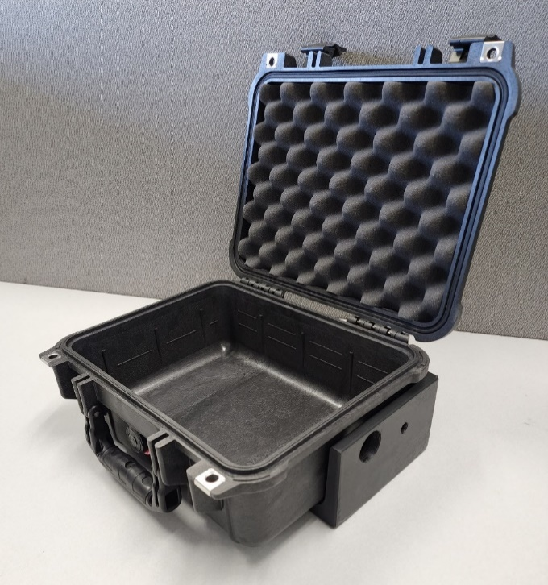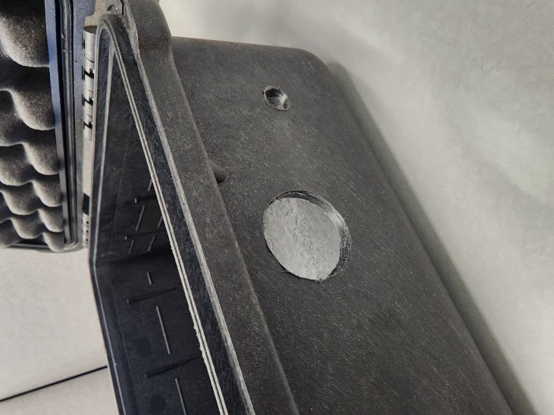

1. Insert the Rubber Sealing Gasket (I/N: **3**) into the Pelican Case’s (I/N: **1**) 1-1/4” hole

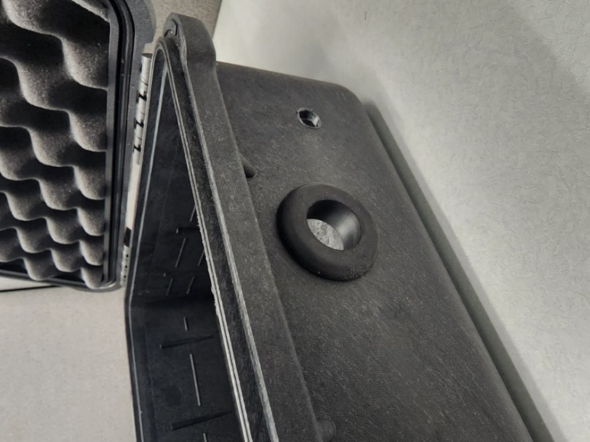

1. Fasten the (C/D: **CN1**) Power Plug (I/N: **28**) to the Case’s (I/N: **1**) 11mm hole

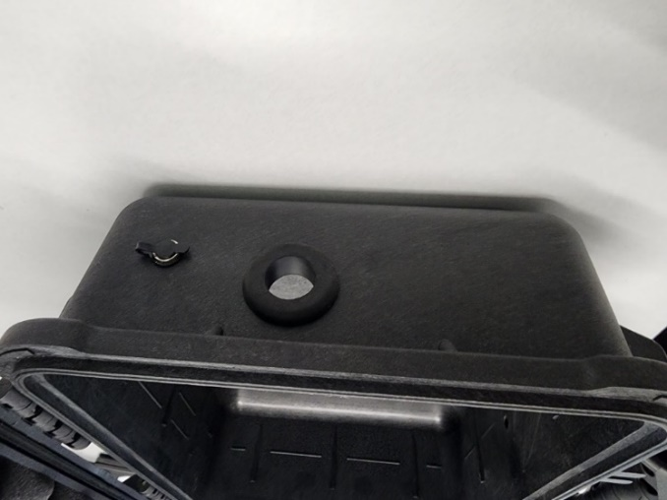

1. Solder & Heat-shrink the female end of the (C/D: **CN2**) 2-Wire Quick-Disconnect Connector’s (I/N: **64**) Positive lead (**RED**) & the Negativelead(**BLACK**) to the (C/D: **CN1**) Power Plug’s (I/N: **28**) Positive lead (**RED**) & Negativelead(**BLACK**)

Note: Wire color of Power Plug can vary depending on manufacture

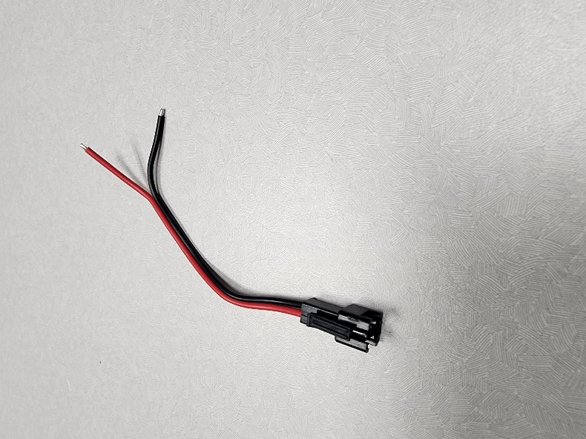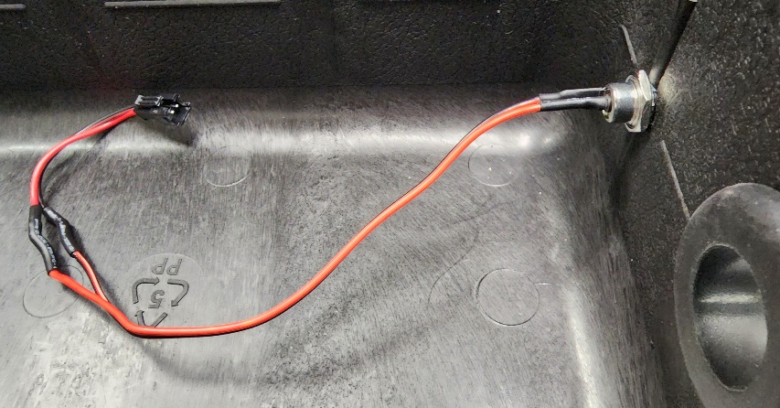

1. Press the #6-32 Brass Inserts into the Panel Kit Accessory’s (I/N: **2**) bottom side

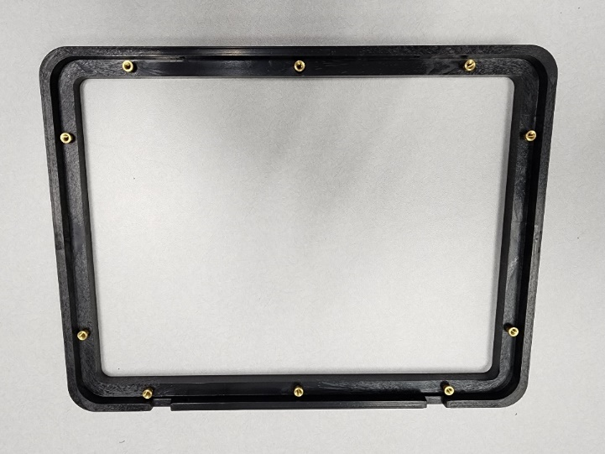

1. Fasten the Panel Kit Accessory (I/N: **2**) to the Pelican Case (I/N: **1**)

Note: On the Panel Kit Accessory (I/N: **2**) position the word “Front” to the front of the Pelican Case (I/N: **1**)

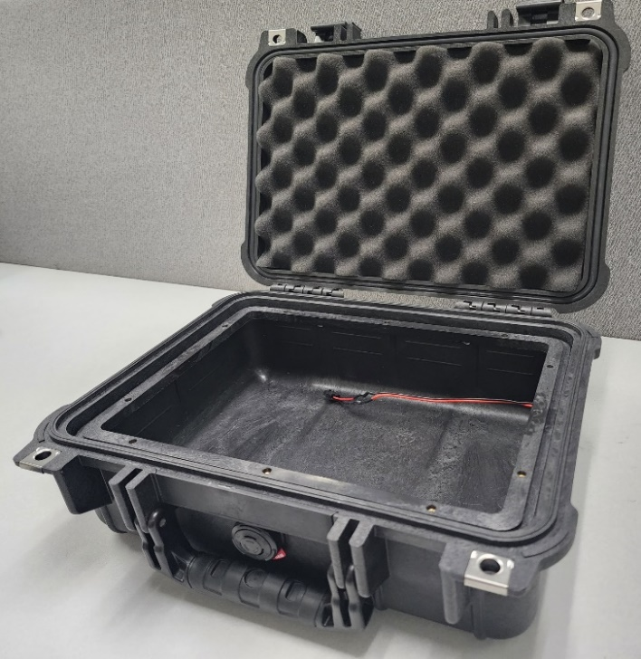

1. Cut 2x (Hook Side) Velcro Strips (I/N: **44**) to 5.5in
2. Peel & stick both (Hook Side) Velcro Strips (I/N: **44**) to the Pelican Case (I/N: **1**)

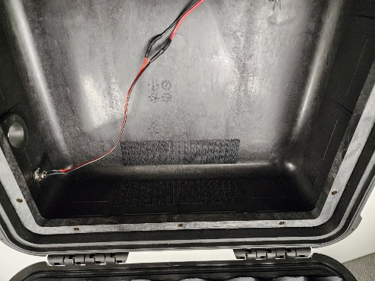

# **Process 2: Power Switch Installation**

|  |  |  |
| --- | --- | --- |
| Item Number (I/N) | Part Number (P/N) | Part Description |
| 4 | FC-001 | Control Panel |
| 26 | 7395K11 | Rocker Power Switch |

## Required Parts:

## Steps:

1. Insert the Rocker Power Switch (I/N: **26**) into the Control Panel (I/N: **4**)

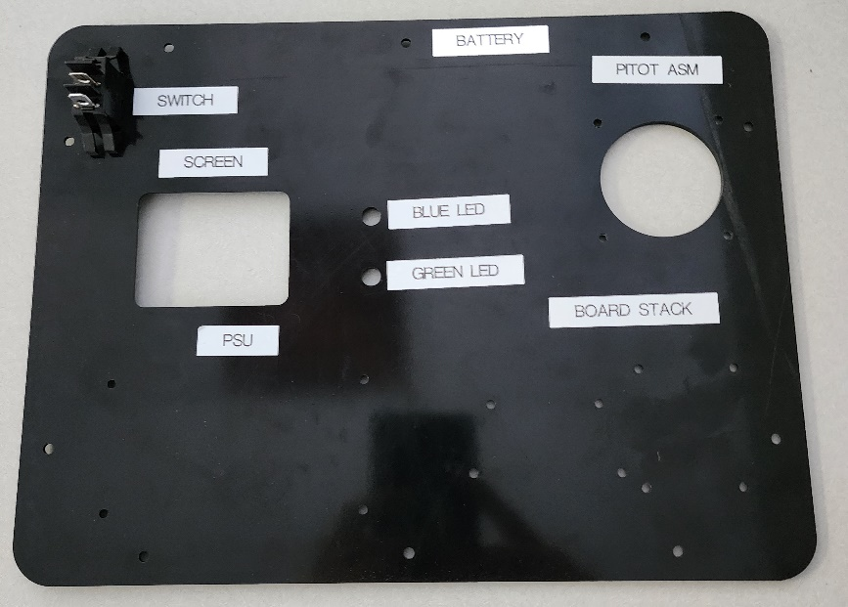

# **Process 3: Install DC-DC Power Supply**

## Required Parts:

|  |  |  |  |
| --- | --- | --- | --- |
| Item Number (I/N) | Part Number (P/N) | Quantity | Part Description |
| 4 | FC-001 | 1 | Control Panel |
| 31 | PSE-24-DC12-40 | 1 | 24v Power Supply (1.67A) |
| 54 | 95947A527 | 4 | 24mm Standoff |
| 58 | 92010A122 | 4 | M3x12mm Flat Head Screws |

## Picture of Required Components:

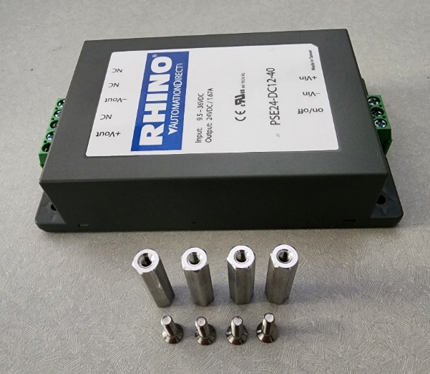

## Steps:

1. Fasten the 24v Power Supply (I/N: **31**) to the Control Panel (I/N: **4)** using the 24mm Standoffs (I/N: **54**)

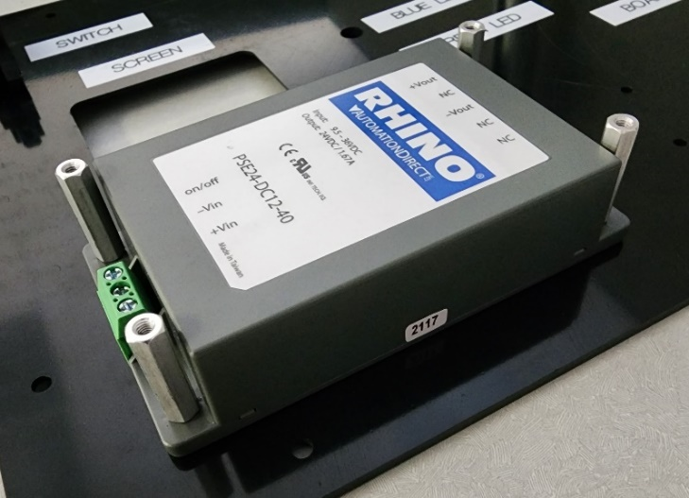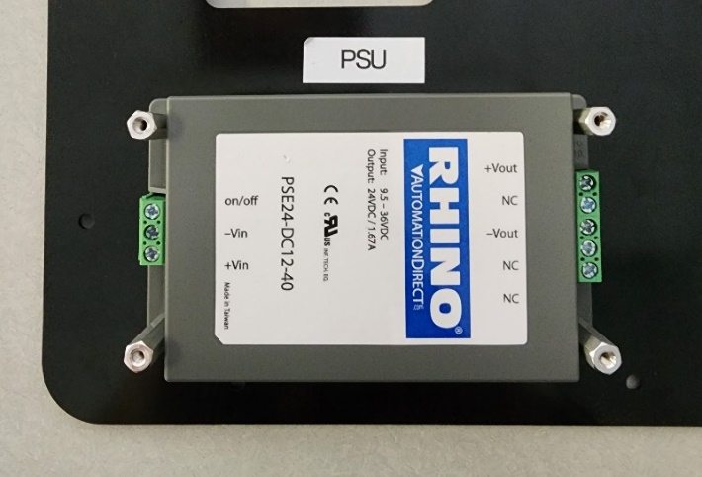

# **Process 4: Install Relay & Power Converter**

## Required Parts:

|  |  |  |  |
| --- | --- | --- | --- |
| Item Number (I/N) | Part Number (P/N) | Quantity | Part Description |
| 4 | FC-001 | 1 | Control Panel |
| 32 | LTC0389-X | 1 | Power Converter (24v/5v) |
| 36 | B079FGPC9Y | 1 | 2-Channel Relay (5v) |
| 50 | B073XP7MZ6 | 4 | 10mm + 6mm Male & Female Standoff |
| 52 | B09V2936PG | 4 | 15mm Standoff |
| 54 | 95947A527 | 4 | 24mm Standoff |
| 58 | 92010A118 | 8 | M3x8mm Flat Head Screws |

## Picture of Required Components:

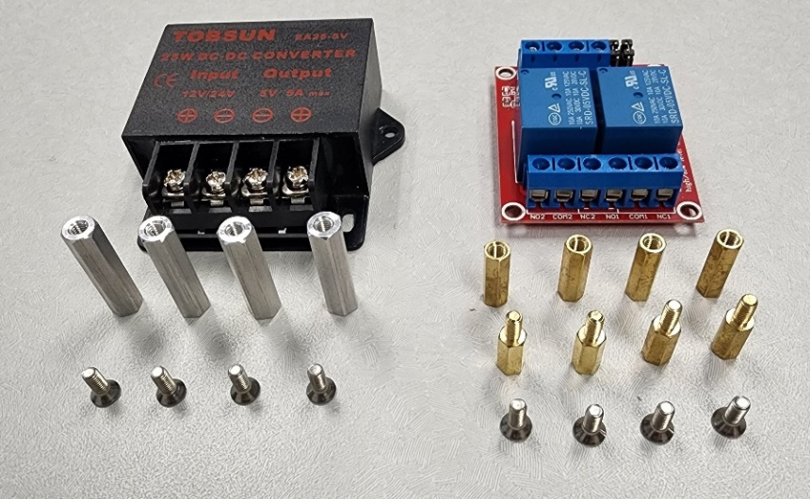

## Steps:

1. Fasten the Power Converter (I/N: **32**) to the Control Panel (I/N: **4**) using the 24mm Standoffs (I/N: **54**)

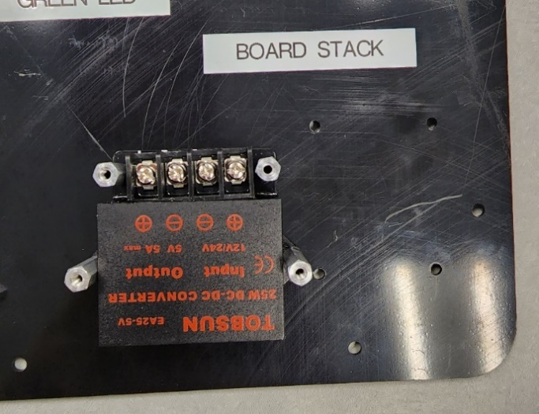

1. Fasten the 10mm + 6mm Standoffs (I/N: **50**) to the Control Panel (I/N: **4**)

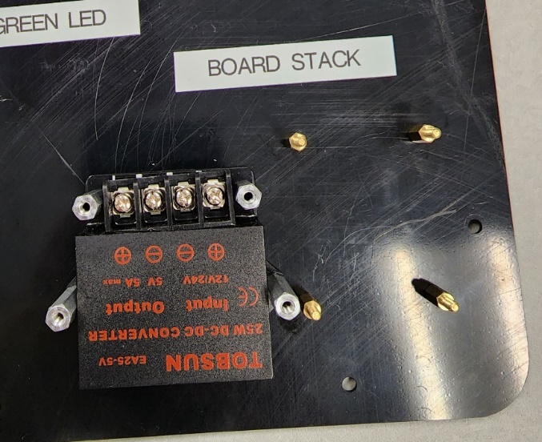

1. Fasten the 2-Channel Relay (I/N: **36**) to the Control Panel (I/N: **4**) using the 15mm Standoffs (I/N: **52**)

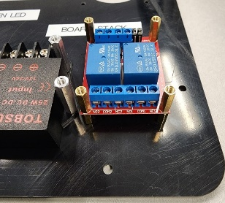

# **Process 5: Install the Battery Switching Relay**

## Required Parts:

|  |  |  |  |
| --- | --- | --- | --- |
| Item Number (I/N) | Part Number (P/N) | Quantity | Part Description |
| 33 | B07B48CW3Y | 1 | Battery Switching Relay |
| 41 | FC-002-1 | 1 | Motor/Power Stacking Board |
| 50 | B073XP7MZ6 | 2 | 10mm + 6mm Male & Female Standoff |
| 55 | B09V2936PG | 2 | M3 Hex Nut |
| 58 | 92010A118 | 2 | M3x8mm Flat Head Screws |

## Picture of Required Components:

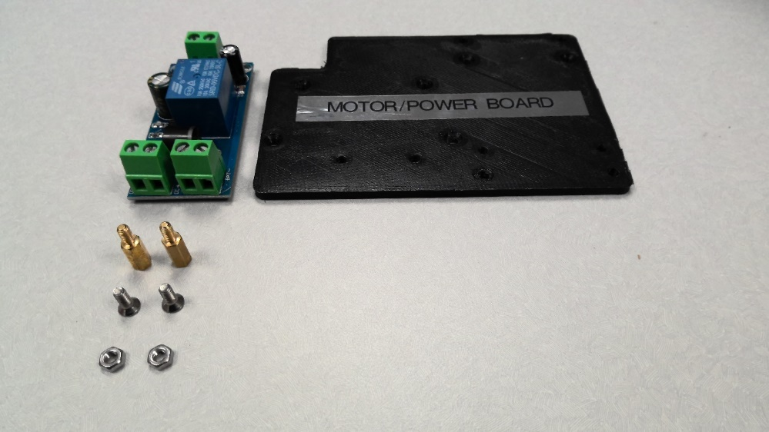

## Steps:

1. Fasten the 10mm + 6mm Standoffs (I/N: **49**) to the Motor/Power Stacking Board (I/N: **41**)
2. Fasten the Battery Switching Relay (I/N: **33**) to the 10mm + 6mm Standoffs (I/N: **50**) using a M3 Hex Nut (I/N: **55**)

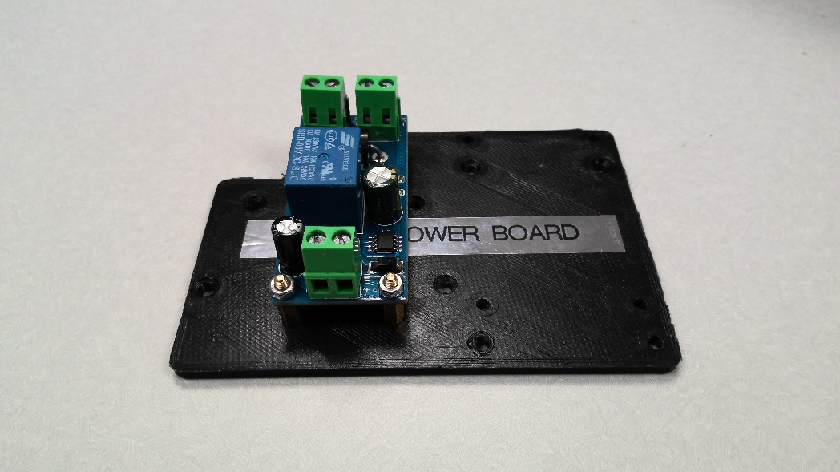

# **Process 6: Wire the Battery Switching Relay, Power Switch & 24v Power Supply**

## Required Parts:

|  |  |  |  |
| --- | --- | --- | --- |
| Item Number (I/N) | Part Number (P/N) | Quantity | Part Description |
| 27 | 9397K15 | 2 | Soldered-Loaded Female Spade |
| 67 | SW16A252008F25C5_RBWBBG | * | 16-Gauge Wire |
|  |  | 5 | Zipties (Optional) |

## Steps:

1. Wire the **Out+ pin** on the (C/D: **K1**) Battery Switching Relay (I/N: **33**) to the **#2 pin** on the (C/D: **S1**) Power Switch (I/N: **26**)
2. Wire the **#1 pin** on the(C/D: **S1**)Power Switch (I/N: **26**) to the **Vin+ pin** on the (C/D: **G2**) 24v Power Supply (I/N: **31**)
3. Wire the **Out- pin** on the(C/D: **K1**)Battery Switching Relay (I/N: **33**) to the **Vin- pin** on the (C/D: **K1**) 24v Power Supply (I/N: **31**)

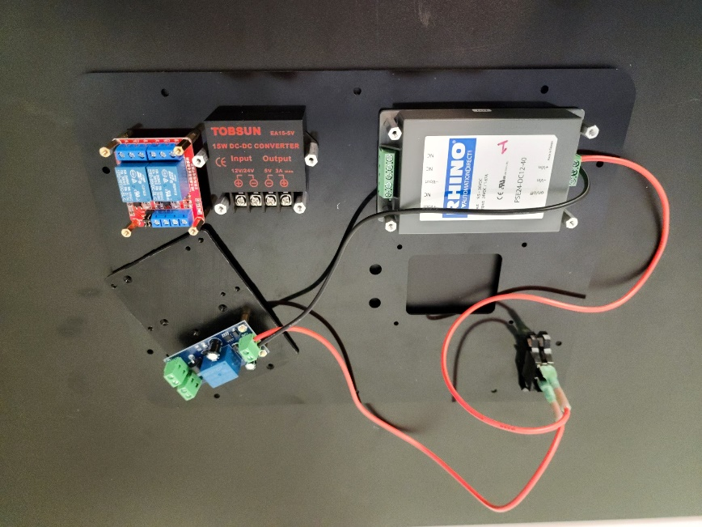

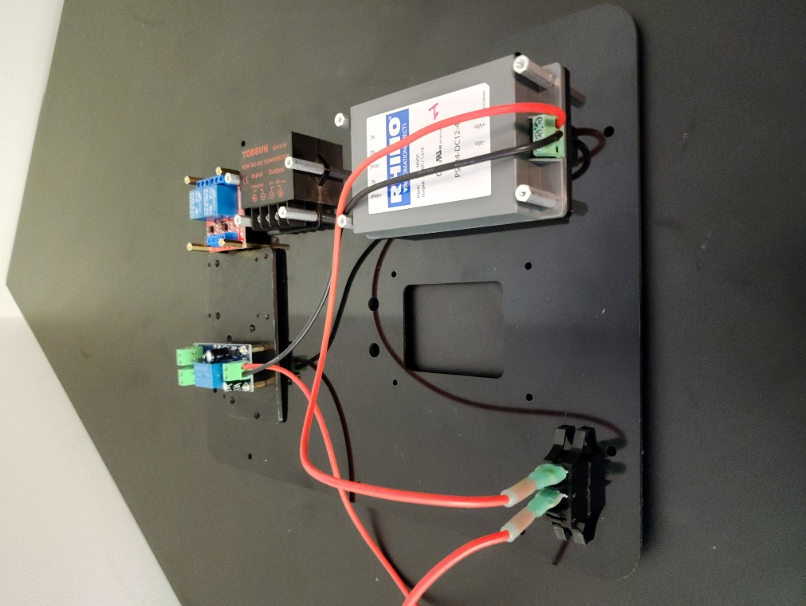

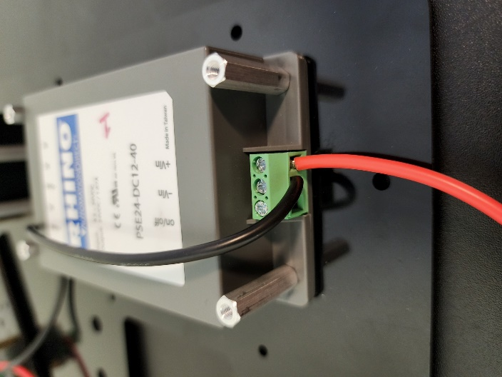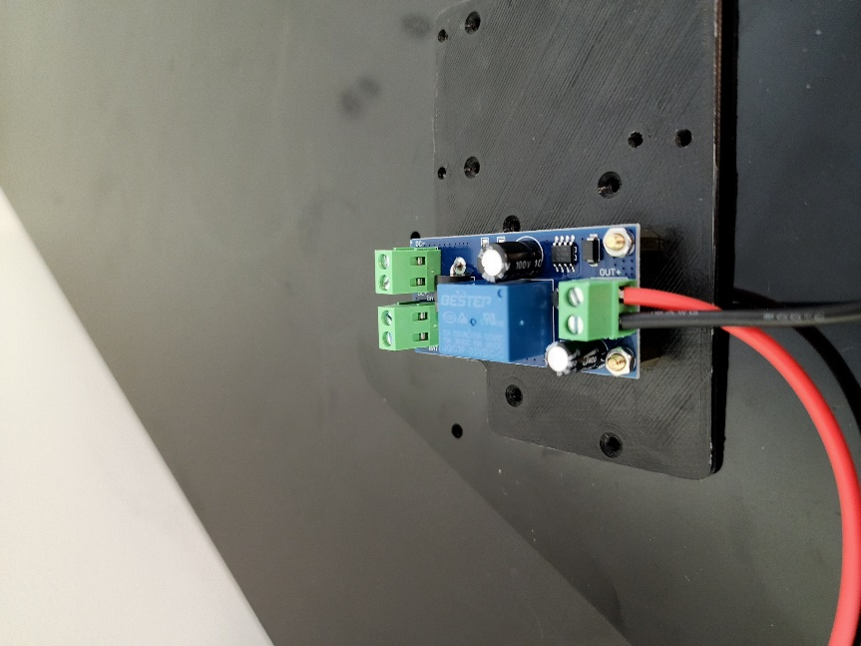

# **Process 7: Wire the 2-Channel Relay, Power Converter & 24v Power Supply**

## Required Parts:

|  |  |  |
| --- | --- | --- |
| Item Number (I/N) | Part Number (P/N) | Part Description |
| 67 | SW16A252008F25C5_RBWBBG | 16-Gauge Wire |
| 68 | SW22A60008F30C10 | 22-Gauge Wire |

## Steps:

1. Wire the (C/D: **G2**) 24v Power Supply (I/N: **31**) to the **24v+ & 24v- pins** on the (C/D: **G3**) Power Converter (I/N: **32**)
2. Wire the (C/D: **G3**) Power Converter (I/N: **32**) to the **5v+ & 5v- pins** on the (C/D: **K2**) 2-Channel Relay (I/N: **36**)

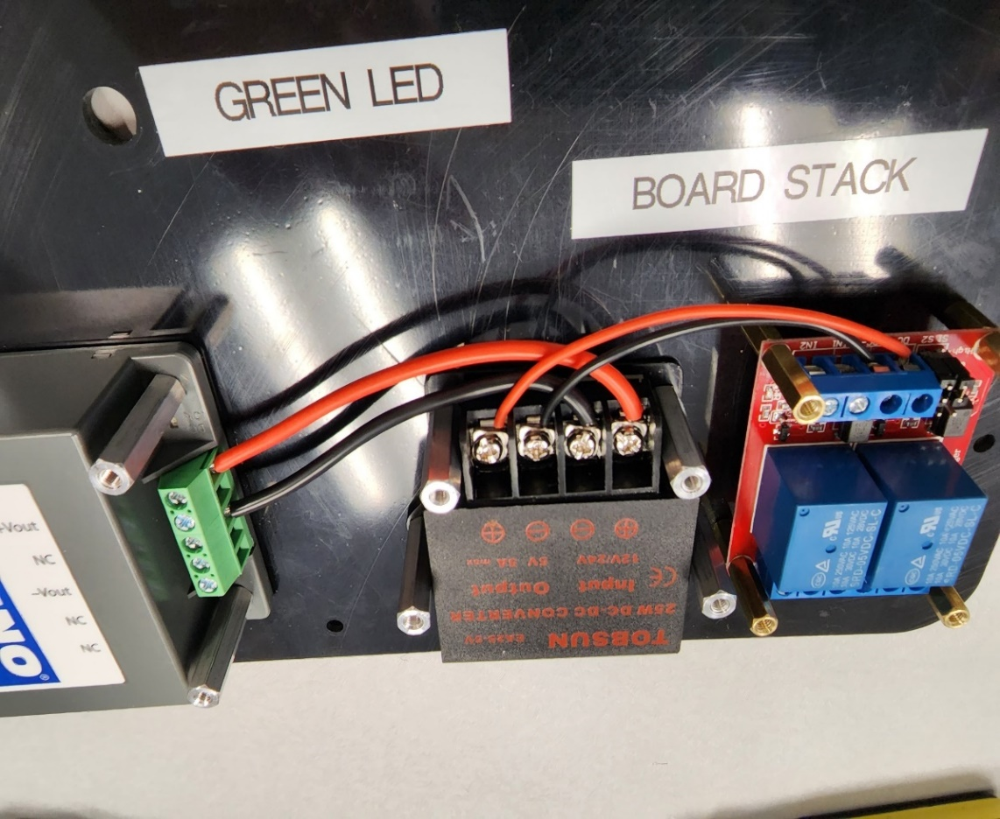

# **Process 8: Install the Teensy System / Wire Blue & Green LED**

## Required Parts:

|  |  |  |  |
| --- | --- | --- | --- |
| Item Number (I/N) | Part Number (P/N) | Quantity | Part Description |
| 4 | FC-001 | 1 | Control Panel |
| 34 | 43201513 | 1 | Teensy 4.1 Terminal Board |
| 35 | TEENSY41 | 1 | Teensy 4.1 Development Board |
| 38 | B08G4VCQ84 | 1 | Blue LED |
| 39 | B08G4XRKRX | 1 | Green LED |
| 42 | FC-002-2 | 1 | Teensy Stacking Board |
| 55 | B09V2936PG | 2 | M3 Hex Nut |
| 56 | 90116A153 | 4 | M3x8mm Pan Head Screw |
| 57 | 90116A157 | 2 | M3x12mm Pan Head Screw |

## Picture of Required Components:

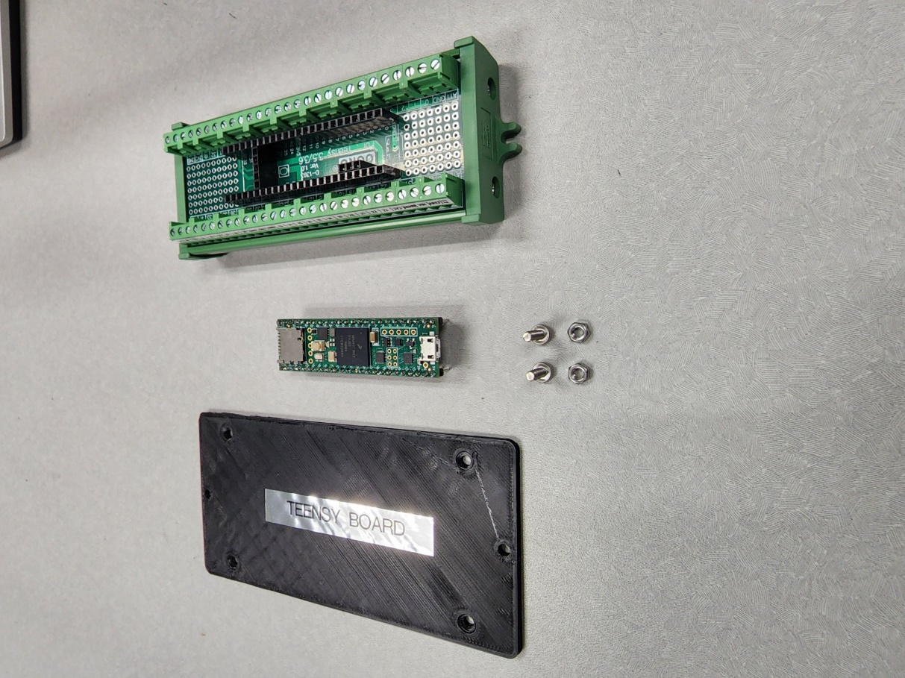 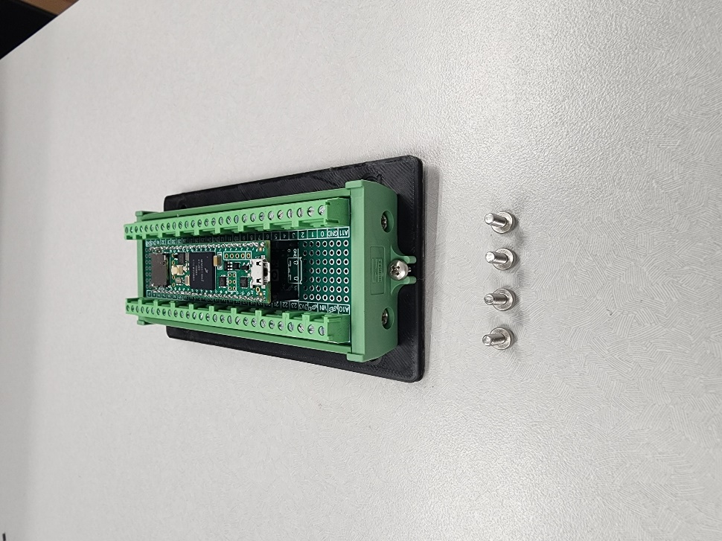

## Steps:

1. Plug (C/D: **N1**) Teensy 4.1 (I/N: **35**) into the (C/D: **J1**)Teensy 4.1 Terminal Board (I/N: **34**)
2. Fasten the (C/D: **J1**)Teensy 4.1 Terminal Board (I/N: **34**) to the Teensy Stacking Board (I/N: **42**)

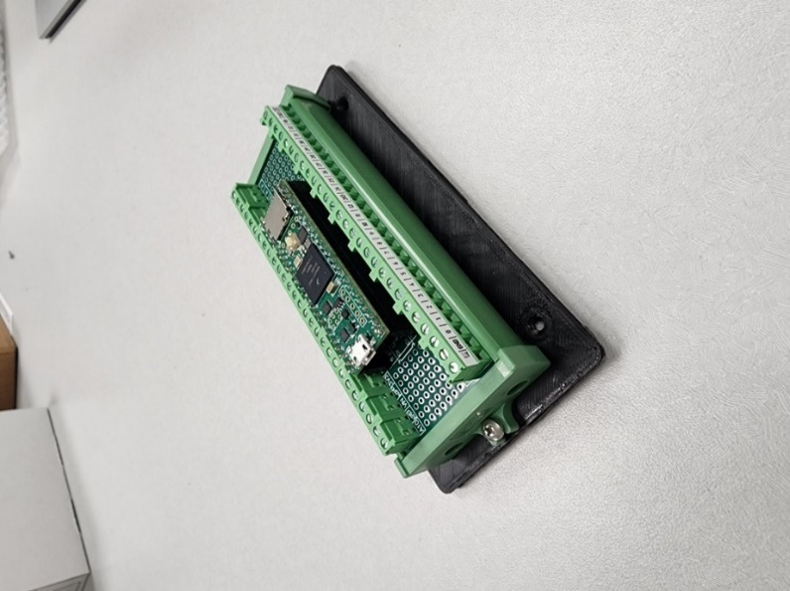

1. Fasten the Teensy Stacking Board (I/N: **42**) to the Control Panel (I/N: **4**)
2. Fasten the (C/D: **H2**) Blue LED (I/N: **38**) & (C/D: **H1**) Green LED (I/N: **39**) to the Control Panel (I/N: **4**)
3. Wire the (C/D: **H2**) Blue LED (I/N: **38**) to the **#6 & GND pins** on the Teensy 4.1 (I/N: **35**)
4. Wire the (C/D: **H1**) Green LED (I/N: **39**) to the **#5 & GND pins** on the Teensy 4.1 (I/N: **35**)

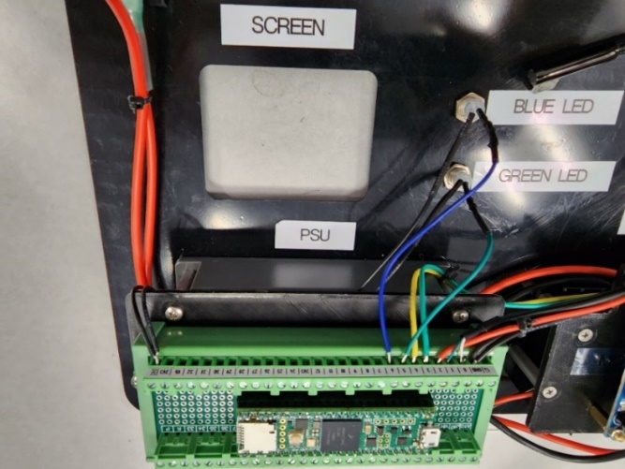

# **Process 9: Wire the 2-Channel Relay, Power Converter & Teensy 4.1**

|  |  |  |  |
| --- | --- | --- | --- |
| Item Number (I/N) | Part Number (P/N) | Quantity | Part Description |
| 18 | B07VJNQT6F | 1 | 90° USB-C Cable |
| 32 | LTC0389-X | 1 | Power Converter (24v/5v) |
| 34 | SW22A60008F30C10 | 1 | Teensy 4.1 Terminal Board |
| 35 | TEENSY41 | 1 | Teensy 4.1 Development Board |
| 36 | B079FGPC9Y | 1 | 2-Channel Relay (5v) |
| 67 | SW16A252008F25C5_RBWBBG | * | 16-Gauge Wire |
| 68 | SW22A60008F30C10 | * | 22-Gauge Wire |
|  |  | 5 | Zipties (Optional) |

## Required Parts:

## Steps:

1. Wire the **#3 & #4 pins** on the (C/D: **J1**) Teensy 4.1 Terminal Board (I/N: **34**) to the **IN1 & IN2 pins** on the (C/D: **K2**)2-Channel Relay (I/N: **36**)
2. Wire the **Vin & GND** **pins** on the(C/D: **J1**) Teensy 4.1 Terminal Board (I/N: **34**) to the **5v+ & 5v- pins** on the (C/D: **G3**) Power Converter (I/N: **32**)

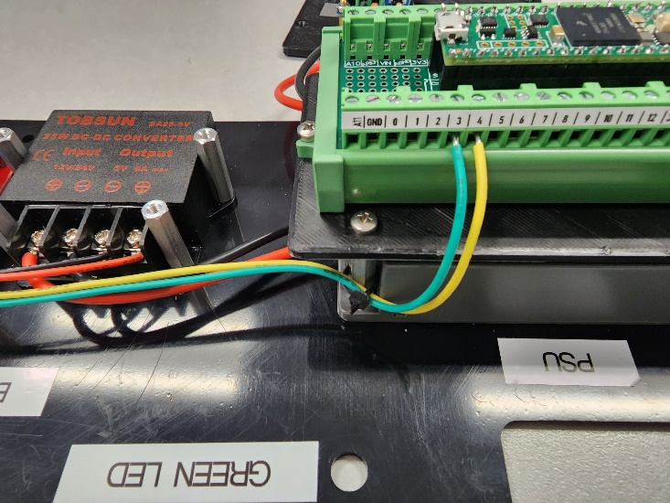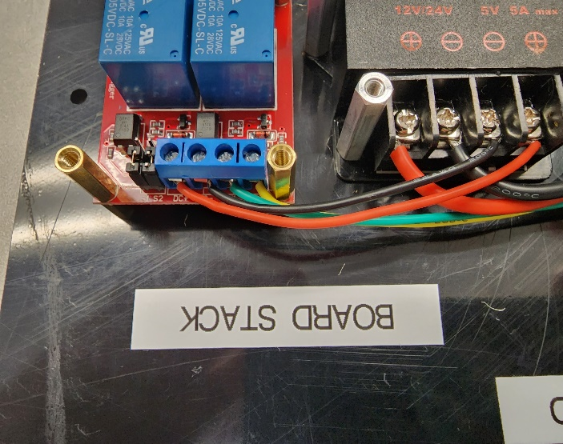

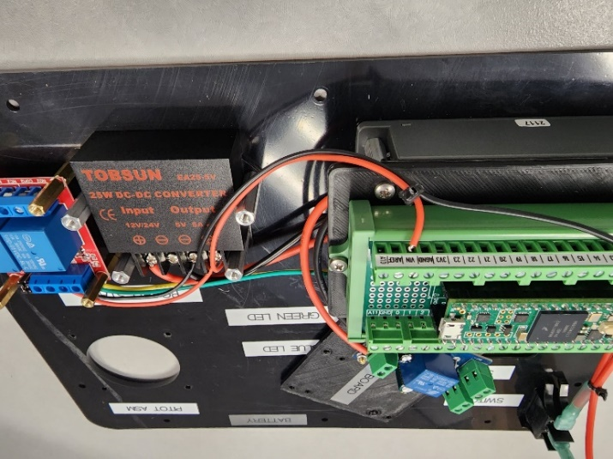

1. Wire the **5v pin** on the (C/D: **K2**) 2-Channel Relay (I/N: **36**) to the **COM1 pin** on the (C/D: **K2**) 2-Channel Relay (I/N: **36**)
2. Strip and prepare the USB-C Cable (I/N: **18**)
3. Wire the **Vin+** **Lead** on the USB-C Cable (I/N: **18**) to the **NO1** **pin** on the (C/D: **K2**) 2-Channel Relay (I/N: **36**)
4. Wire the **Vin-** **Lead** on the USB-C Cable (I/N: **18**) to the **GND** **pin** on the (C/D: **K2**) 2-Channel Relay (I/N: **36**)

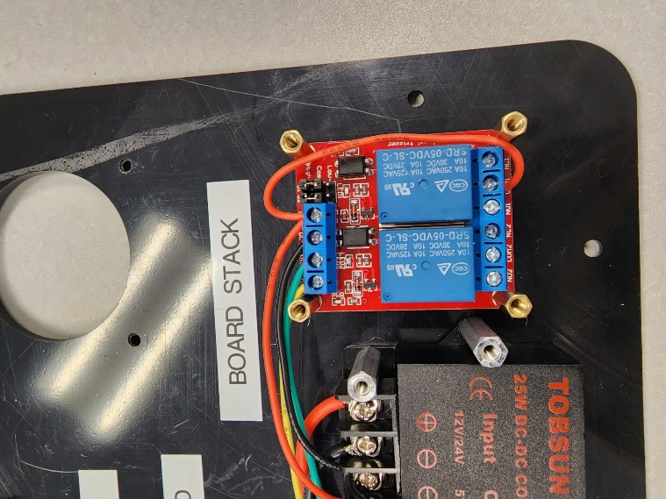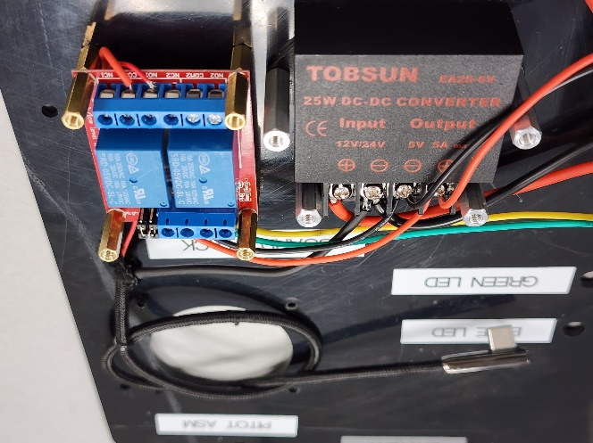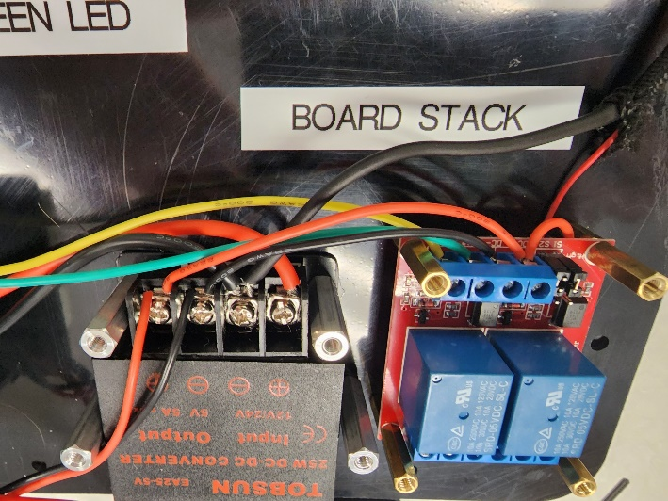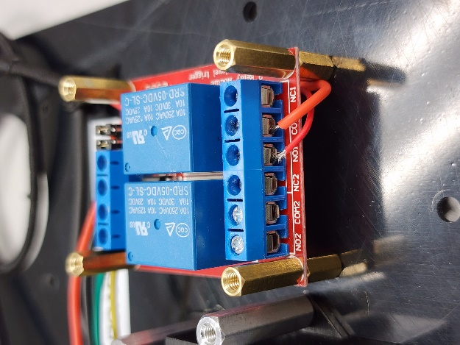

1. Wire two open leaded wires to be used later in **Process 14** from the **24v+ & 24v- pins** on the (C/D: **G3**) Power Converter (I/N: **32**)
2. Wire the **24v+ pin** on the (C/D: **G3**) Power Converter (I/N: **32**) to the **COM2 pin** on the (C/D: **K2**) 2-Channel Relay (I/N: **36**)

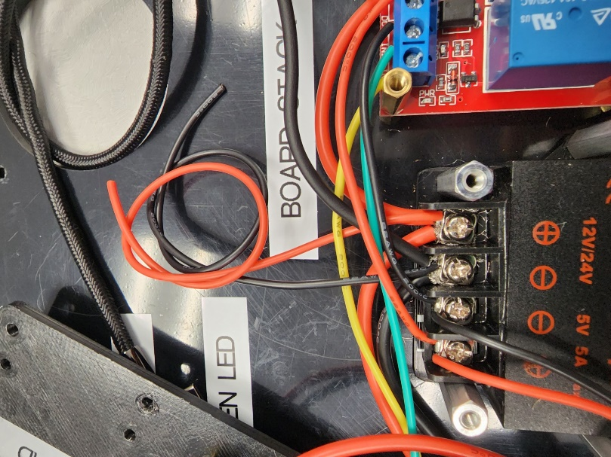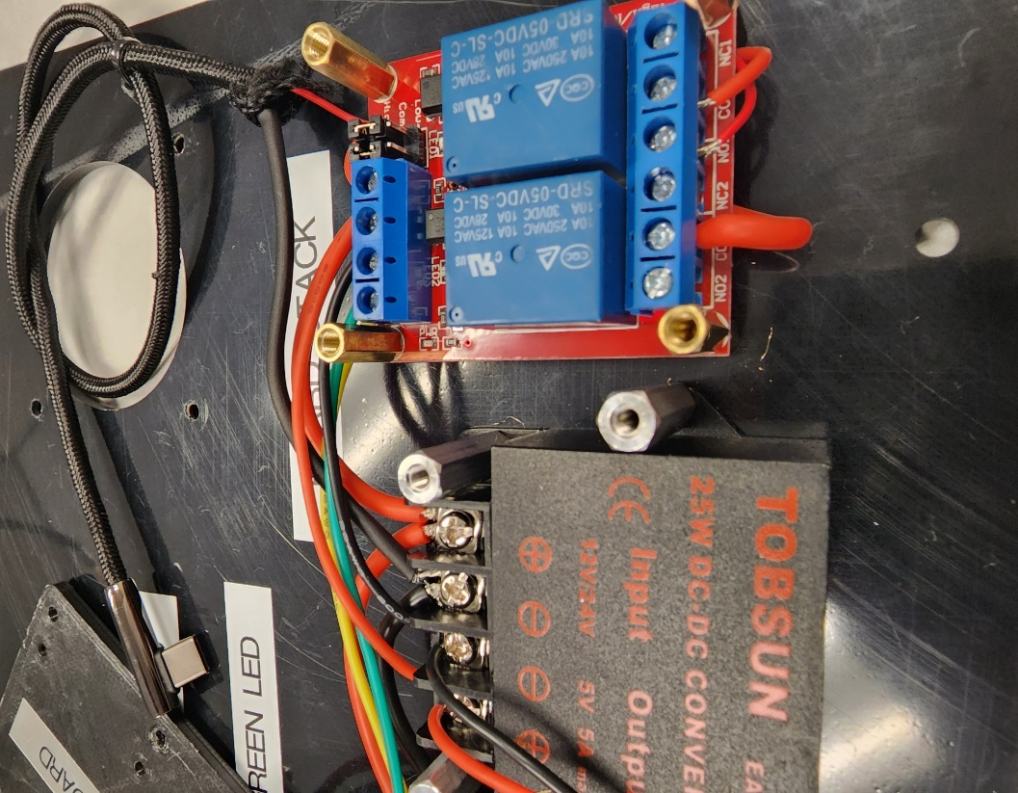

# **Process 10: Wire the 24v BLDC Motor Controller to the Micronel Fan Blower**

## Required Parts:

|  |  |  |
| --- | --- | --- |
| Item Number (I/N) | Part Number (P/N) | Part Description |
| 14 | JYQD_V7.3E2 | 24v BLDC Motor Controller |
| 15 | U65ML-024KS-5 | BLDC Fan Blower |
| 32 | LTC0389-X | Power Converter (24v/5v) |
| 36 | B079FGPC9Y | 2-Channel Relay (5v) |
| 65 | CAB-14575 | 3-Wire Quick-Disconnect Molex Connector |

## Steps:

1. Wire the **MA** **pin** on the (C/D: **E1**) 24v BLDC Motor Controller (I/N: **14**) to the **#1 pin** on the female connectors side of the (C/D: **CN3**) 3-Wire Quick-Disconnect (I/N: **65**)
2. Wire the **MB** **pin** on the (C/D: **E1**) 24v BLDC Motor Controller (I/N: **14**) to the **#2 pin** on the female connectors side of the (C/D: **CN3**) 3-Wire Quick-Disconnect (I/N: **65**)
3. Wire the **MC** **pin** on the (C/D: **E1**) 24v BLDC Motor Controller (I/N: **14**) to the **#3 pin** on the female connectors side of the (C/D: **CN3**) 3-Wire Quick-Disconnect (I/N: **65**)
4. Wire the **#1 pin** on the male connectors side of the (C/D: **CN3**) 3-Wire Quick-Disconnect (I/N: **65**) to the Orange **Motor Winding 1 pin** on the (C/D: **M1**) BLDC Fan Blower (I/N: **15**)
5. Wire the **#2 pin** on the male connectors side of the (C/D: **CN3**) 3-Wire Quick-Disconnect (I/N: **65**) to the Red **Motor Winding 2 pin** on the (C/D: **M1**) BLDC Fan Blower (I/N: **15**)
6. Wire the **#3 pin** on the male connectors side of the (C/D: **CN3**) 3-Wire Quick-Disconnect (I/N: **65**) to the Brown **Motor Winding 3 pin** on the (C/D: **M1**) BLDC Fan Blower (I/N: **15**)

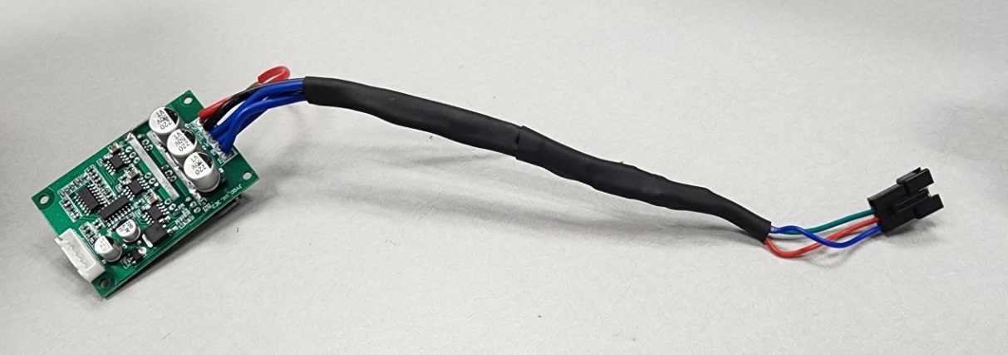 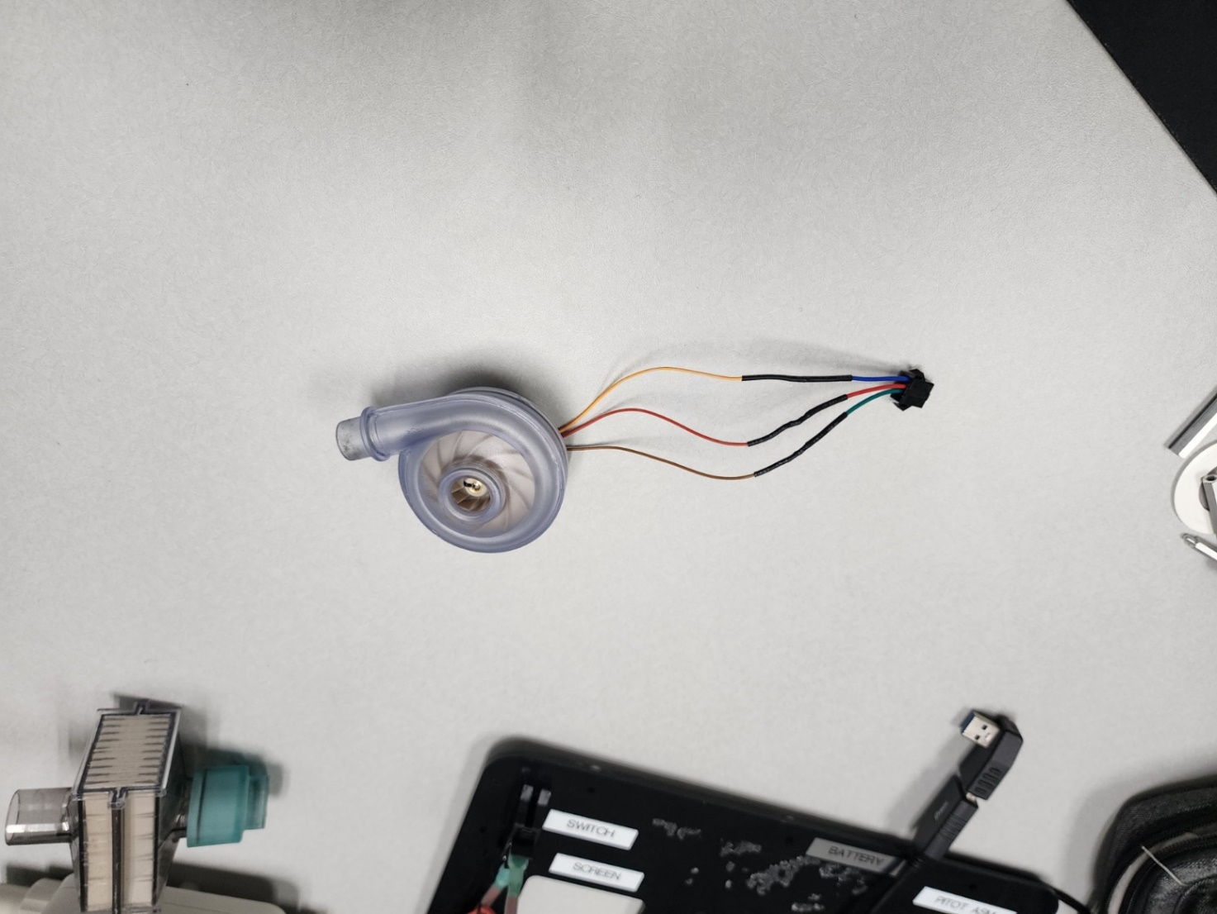

1. Wire the **VCC pin** on the (C/D: **E1**) 24v BLDC Motor Controller (I/N: **14**) to the **NO2 pin** on the (C/D: **K2**) 2-Channel Relay (I/N: **36**)
2. Wire the **GND pin** on the (C/D: **E1**) 24v BLDC Motor Controller’s (I/N: **14**) to the **GND pin** on the (C/D: **G3**) Power Converter (I/N: **32**)

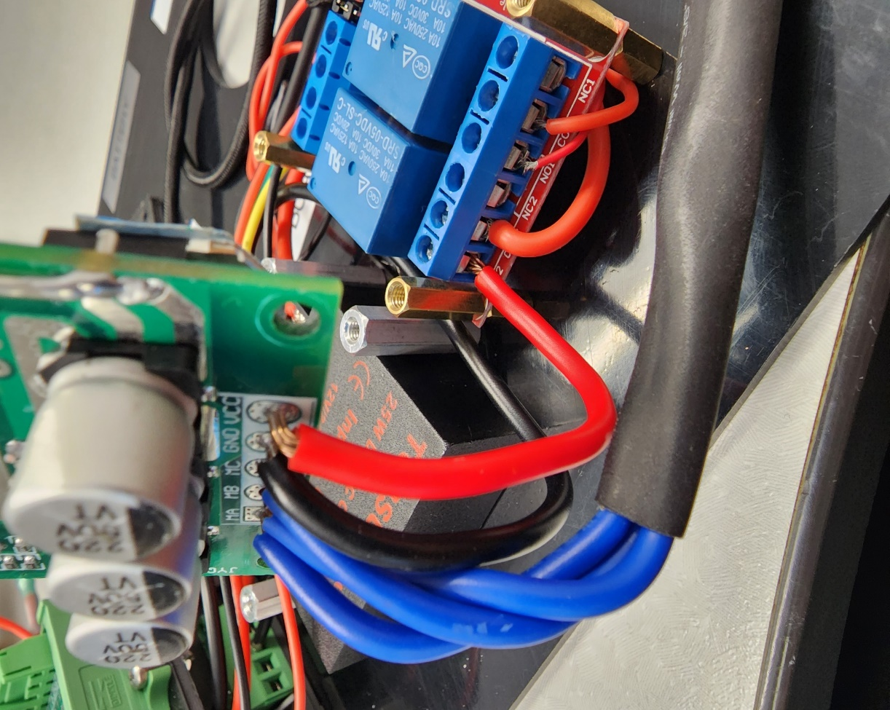

# **Process 11: Install 24 BLDC Motor Controller & Motor/Power Stacking Board**

## Required Parts:

|  |  |  |  |
| --- | --- | --- | --- |
| Item Number (I/N) | Part Number (P/N) | Quantity | Part Description |
| 4 | FC-001 | 1 | Control Panel |
| 14 | JYQD_V7.3E2 | 1 | 24v BLDC Motor Controller |
| 41 | FC-002-1 | 1 | Motor/Power Stacking Board |
| 48 | 93657A207 | 4 | M3 Nylon Spacer |
| 51 | 95947A510 | 2 | M3x13 Standoff |
| 57 | 90116A157 | 4 | M3x12mm Pan Head Screws |
| 58 | 92010A118 | 6 | M3x8mm Flat Head Screws |

## Picture of Required Components:

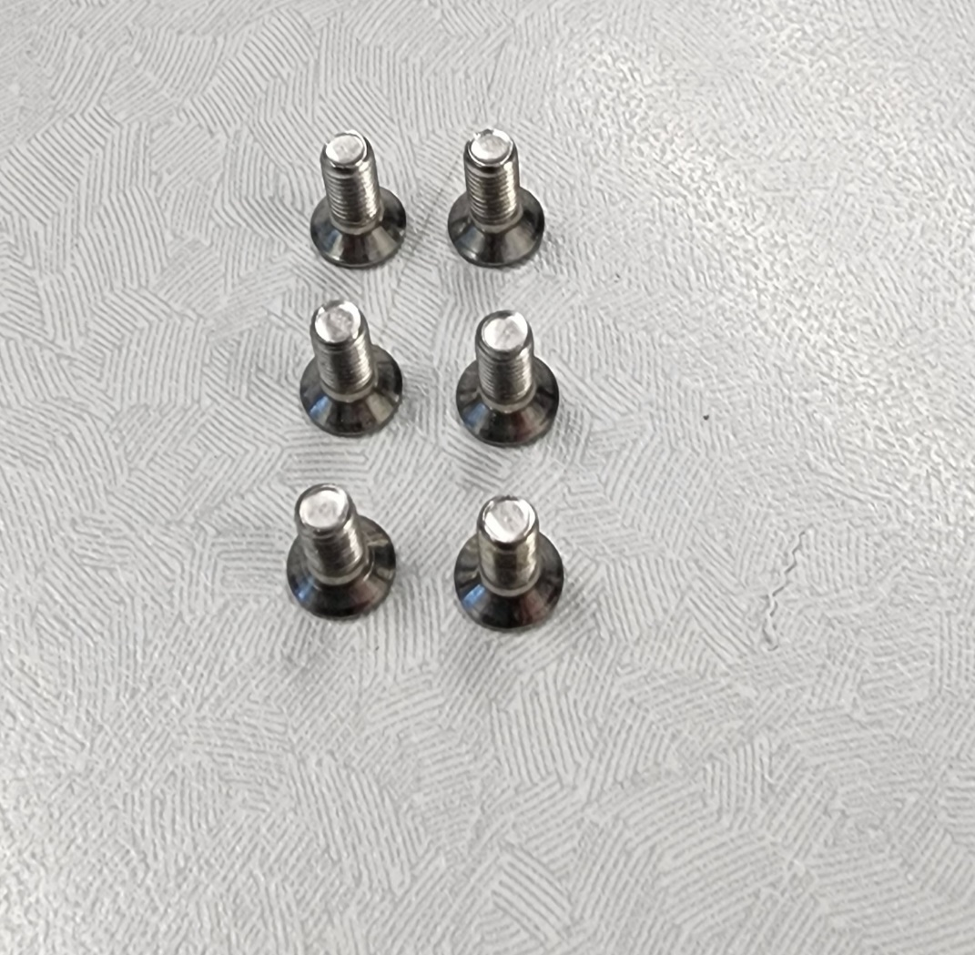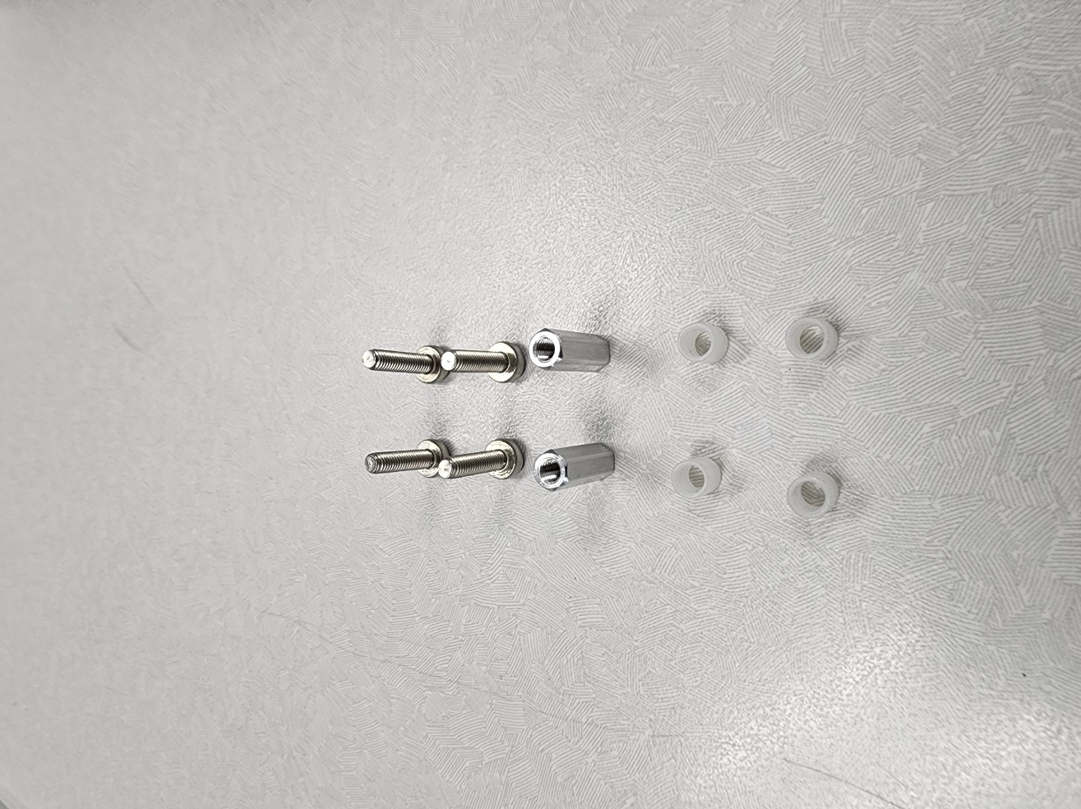

## Steps:

1. Fasten the Motor/Power Stacking Board (I/N: **41**) to the Control Panel (I/N: **4**) with Screws (I/N: **58**)

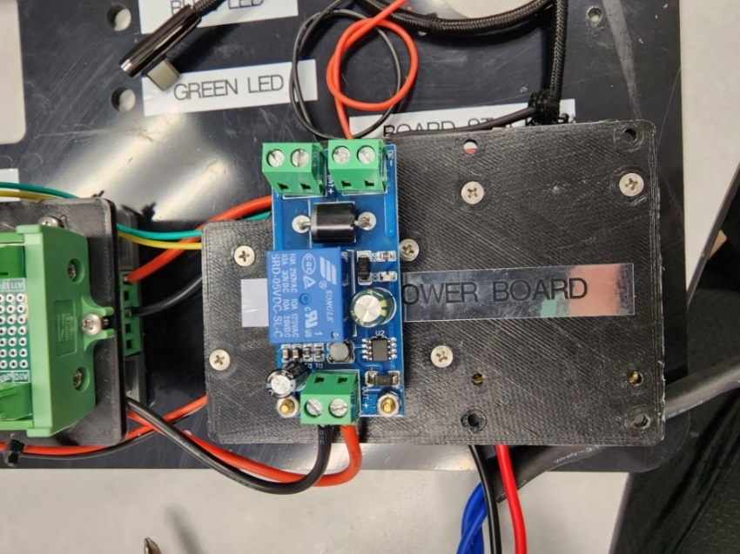

1. Fasten the 24v BLDC Motor Controller (I/N: **14**) to the Motor/Power Stacking Board (I/N: **41**) with Standoffs, Spacers & Screws (I/N: **51**, **48, 57**)

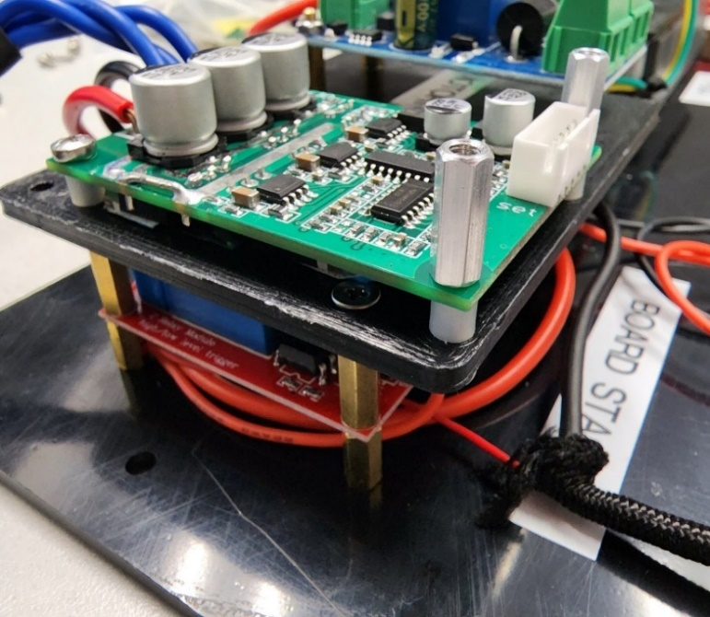

# **Process 12: Install PWM to Analog Converter**

## Required Parts:

|  |  |  |  |
| --- | --- | --- | --- |
| Item Number (I/N) | Part Number (P/N) | Quantity | Part Description |
| 37 | FAFEICYA6I34V0OPM | 1 | PWM to Analog Converter |
| 41 | FC-002-1 | 1 | Motor/Power Stacking Board |
| 43 | FC-002-3 | 1 | PWM to Analog Converter Stacking Board |
| 50 | B073XP7MZ6 | 4 | 10mm + 6mm Male & Female Standoff |
| 53 | B09V2936PG | 2 | M3x20mm Standoff |
| 55 | B09V2936PG | 2 | M3 Hex Nut |
| 56 | 90116A153 | 8 | M3x8mm Pan Head Screws |

## Picture of Required Components:

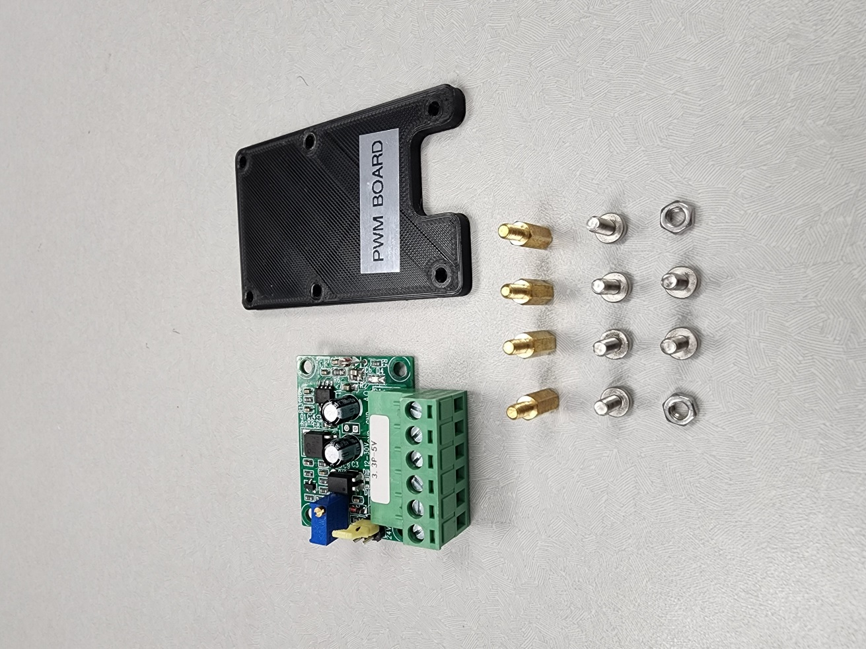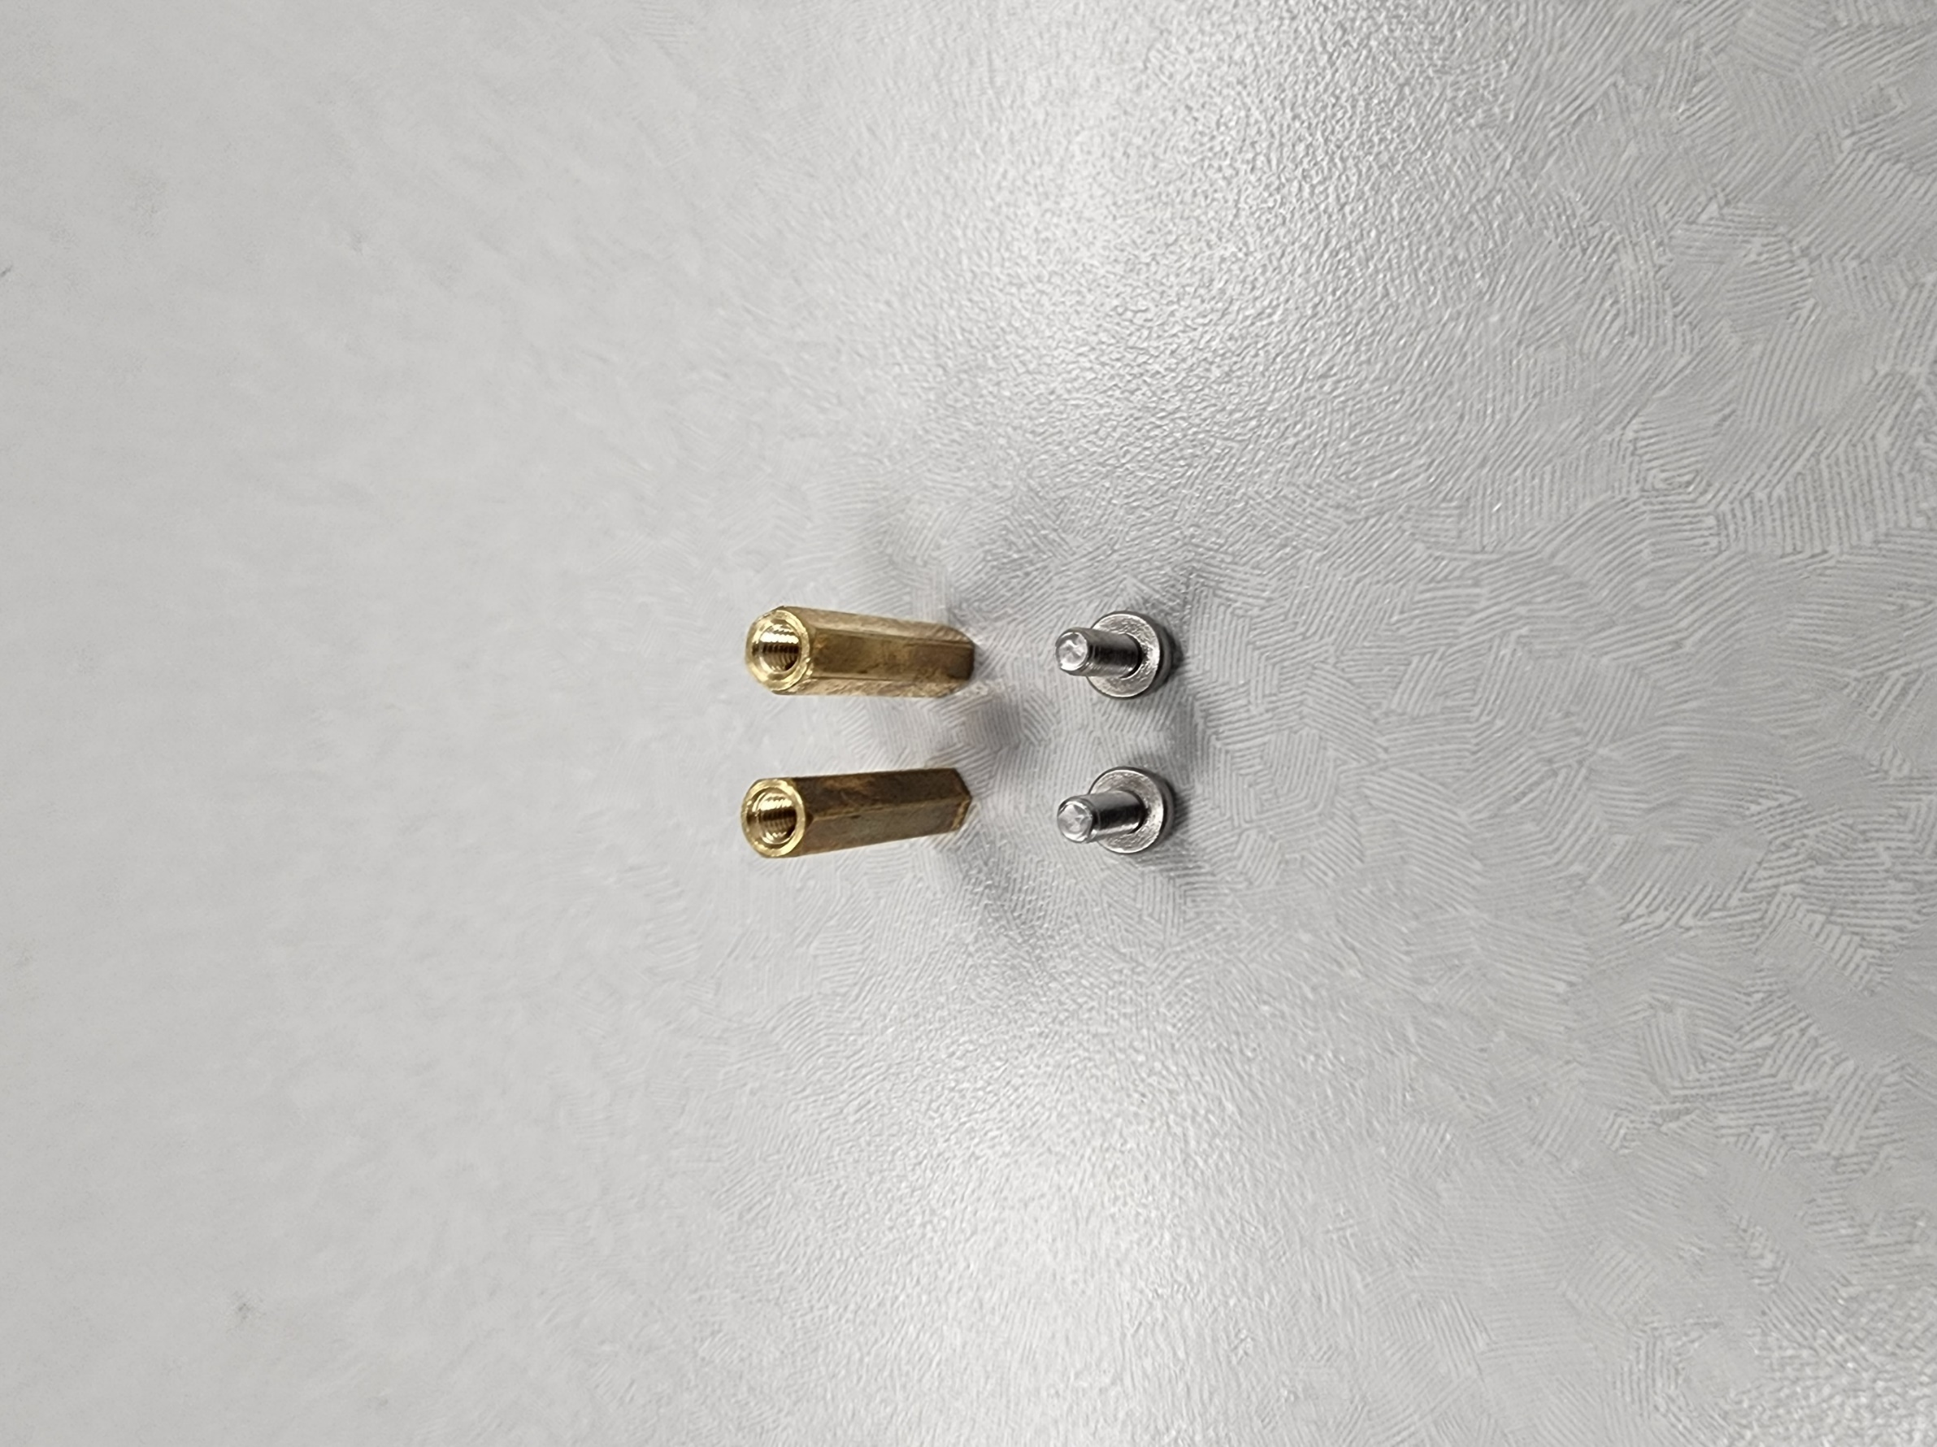

## Steps:

1. Fasten the 20mm Standoffs (I/N: **53**) to the Motor/Power Stacking Board (I/N: **41**)

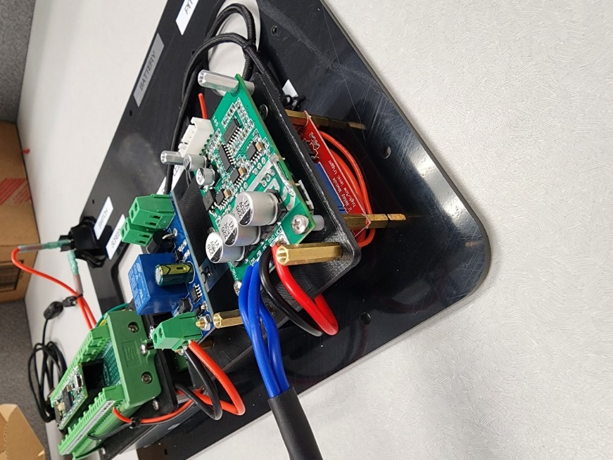

1. Fasten the PWM to Analog Converter Stacking Board (I/N: **43**) to the Motor/Power Stacking Board (I/N: **41**) with Standoffs, Hex Nuts & Screws (I/N: **50, 55, 56**)

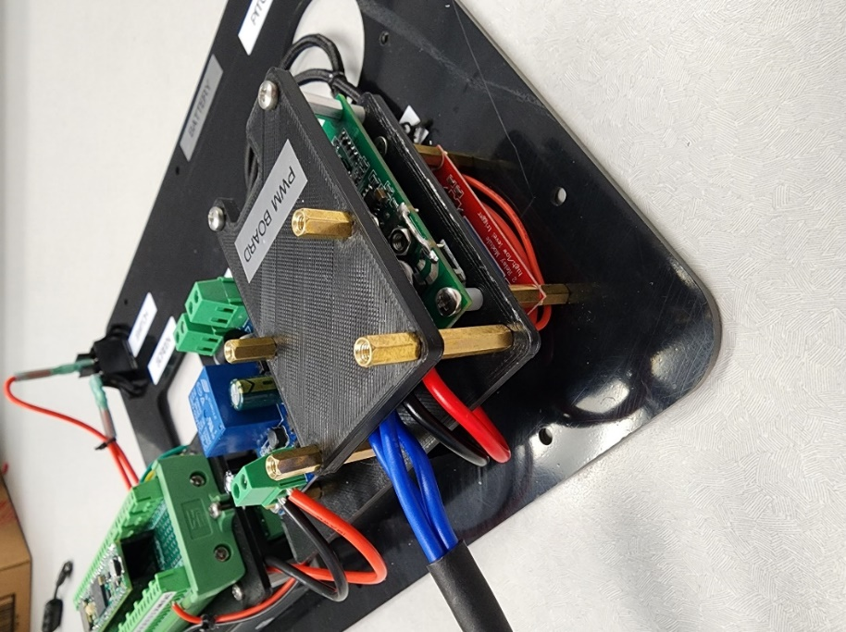

1. Fasten the PWM to Analog Converter (I/N: **37**) to the PWM to Analog Converter Stacking Board (I/N: **43**) with Screws (I/N: **56**)

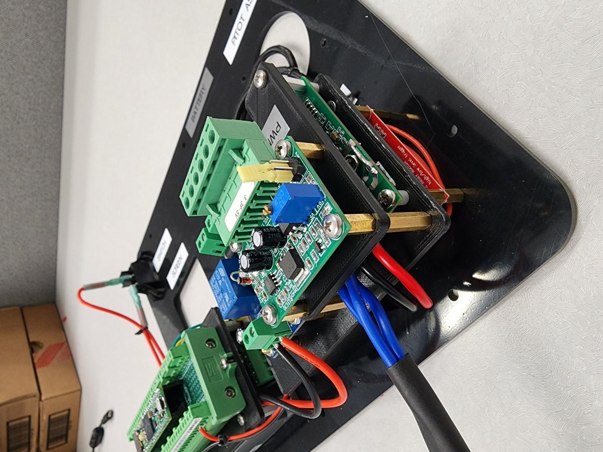

# **Process 13: Wire PWM to Analog Converter & USB Data Cable**

## Required Parts:

|  |  |  |  |
| --- | --- | --- | --- |
| Item Number (I/N) | Part Number (P/N) | Quantity | Part Description |
| 14 | JYQD_V7.3E2 | 1 | 24v BLDC Motor Controller |
| 17 | LR4P-USBMF | 1 | USB 3.0 Adapter |
| 33 | B07B48CW3Y | 1 | Battery Switching Relay |
| 34 | 43201513 | 1 | Teensy 4.1 Terminal Board |
| 35 | TEENSY41 | 1 | Teensy 4.1 Development Board |
| 37 | FAFEICYA6I34V0OPM | 1 | PWM to Analog Converter |
| 40 | DT-6560-1.8m | 1 | USB to TTL Cable |
| 64 | CAB-14574 | .5 | 2-Wire Quick-Disconnect Connector (Female End) |
| 67 | SW16A252008F25C5_RBWBBG | * | 16-Gauge Wire |
| 68 | SW22A60008F30C10 | * | 22-Gauge Wire |
|  |  | 3 | Zipties (Optional) |

## Steps:

1. Wire the two wires left from Process 10 to the **Power Supply (+) & Power Supply (-) pins** on the (C/D: **E2**) PWM to Analog Converter (I/N: **37**)
2. Set the PWM level selection jumper on the PWM to Analog Converter (I/N: **37**) to 5v

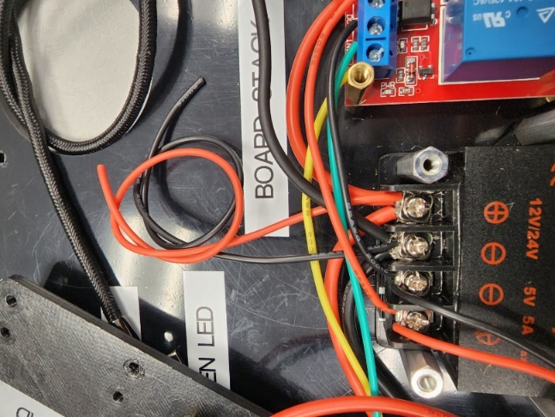

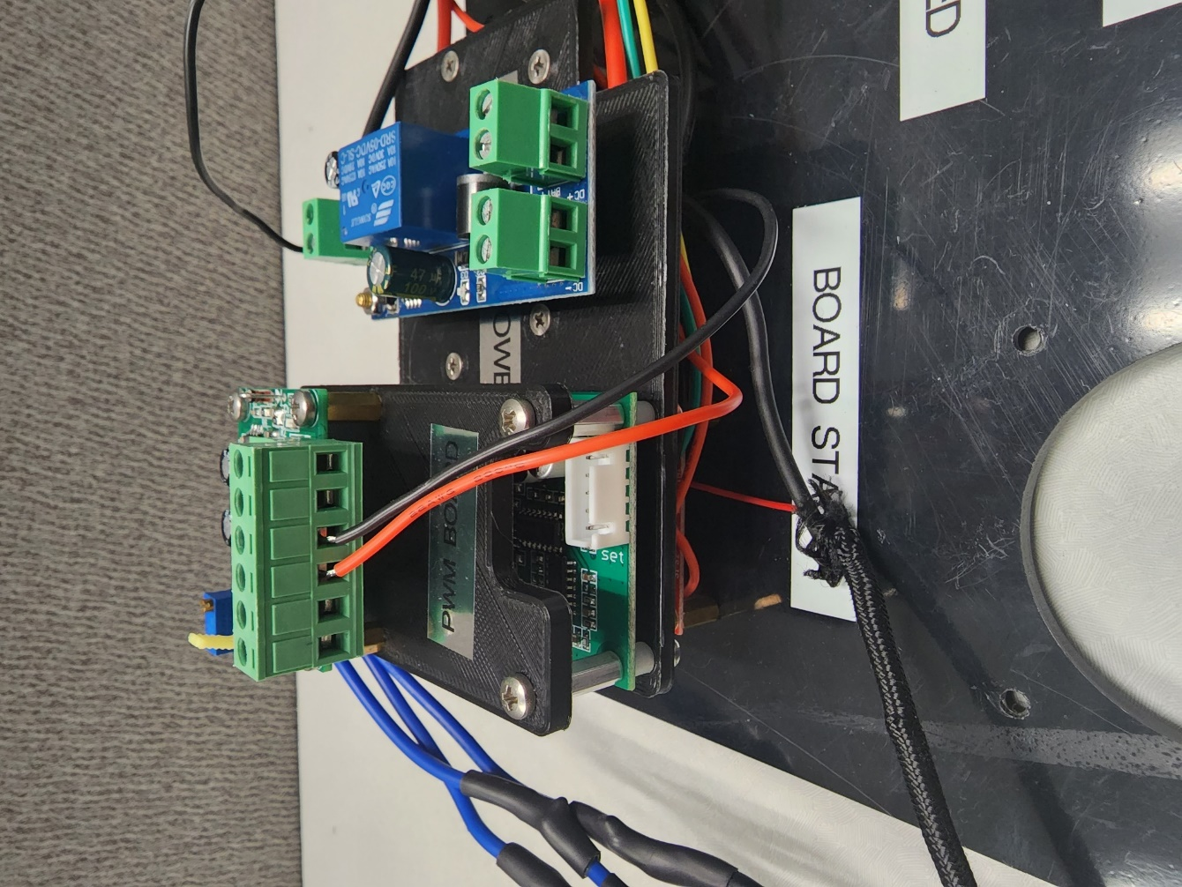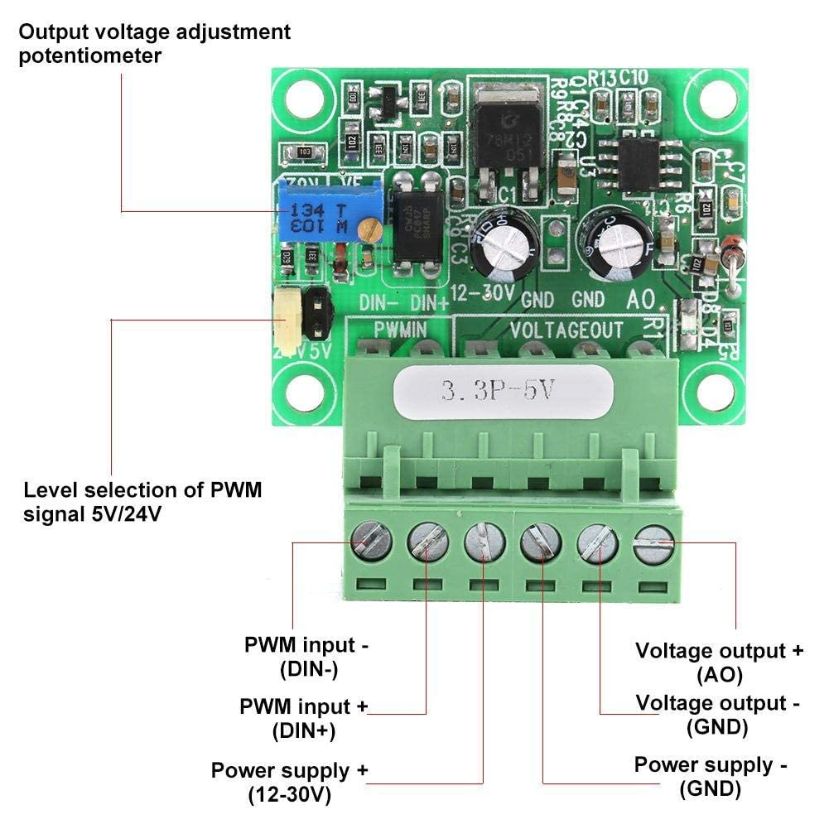

1. Wire the **Din-** & **AO- pins** on the (C/D: **E2**) PWM to Analog Converter (I/N: **37**) to the **GND pins** on the (C/D: **J1**) Teensy 4.1 Terminal Board (I/N: **34**)
2. Wire the **Din+ pin** on the (C/D: **E2**) PWM to Analog Converter (I/N: **37**) to the **#2 pin** on the (C/D: **J1**) Teensy 4.1 Terminal Board (I/N: **34**)

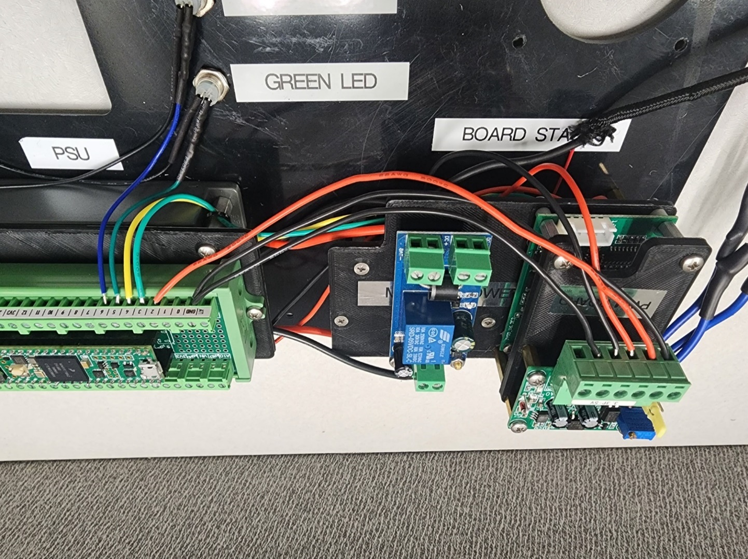

1. Wire the **PWM pin** on the (C/D: **E1**) 24v BLDC Motor Controller (I/N: **14**) to the **AO+ pin** on the (C/D: **E2**) PWM to Analog Converter (I/N: **37**)

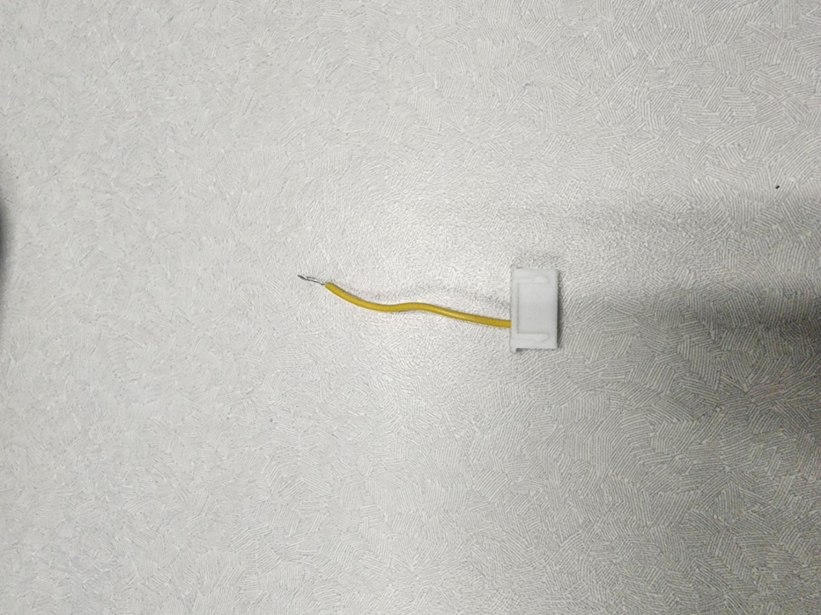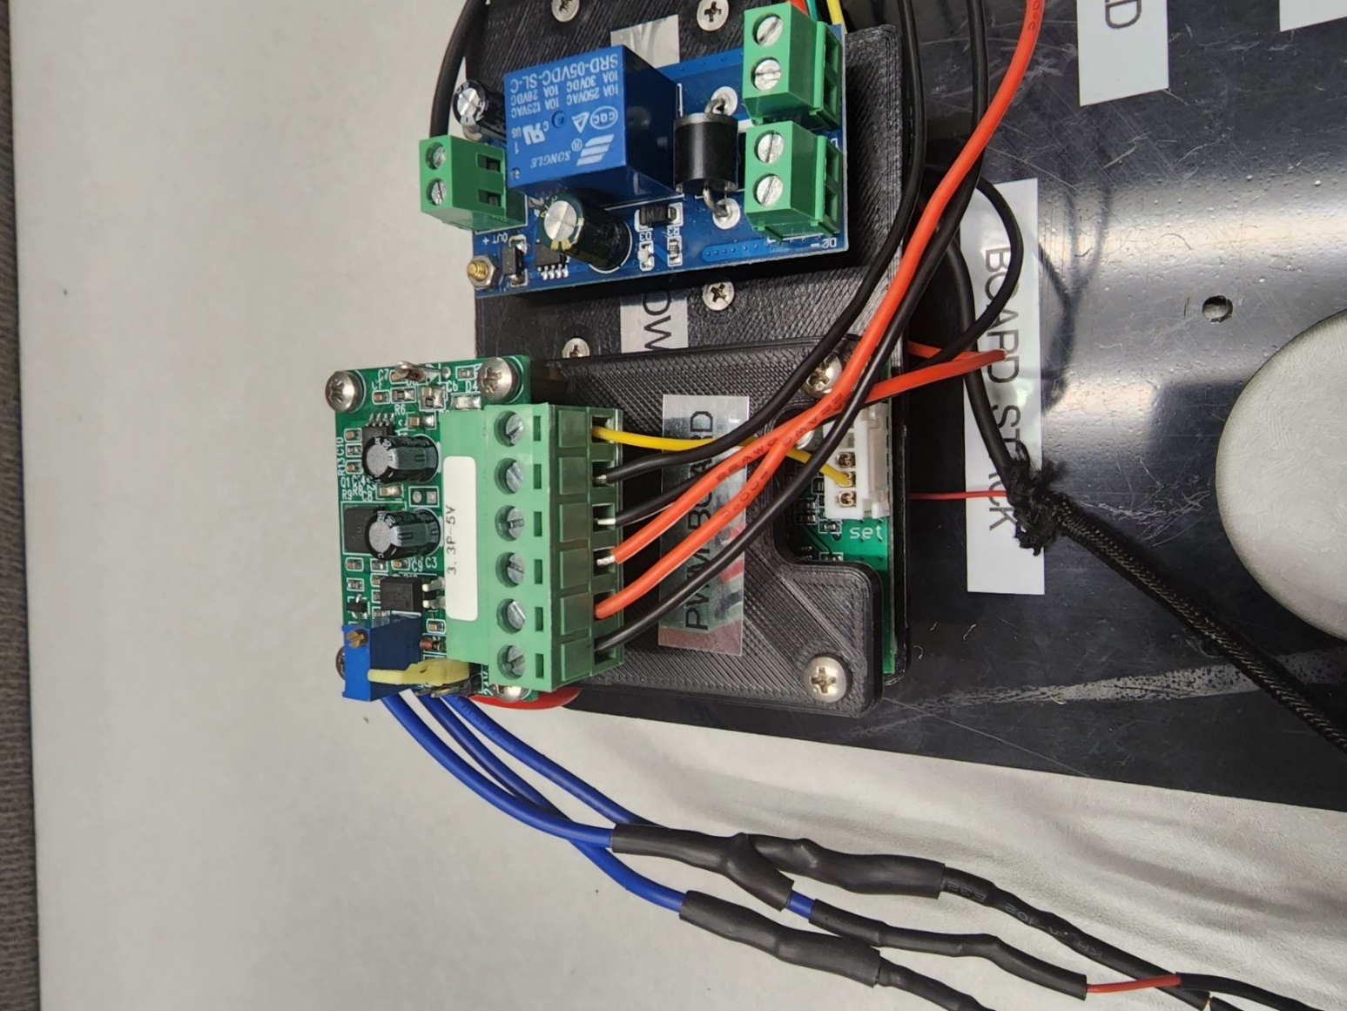

1. Connect the 90° USB Adapter (I/N: **17**) to the USB to TTL Cable (I/N: **40**)

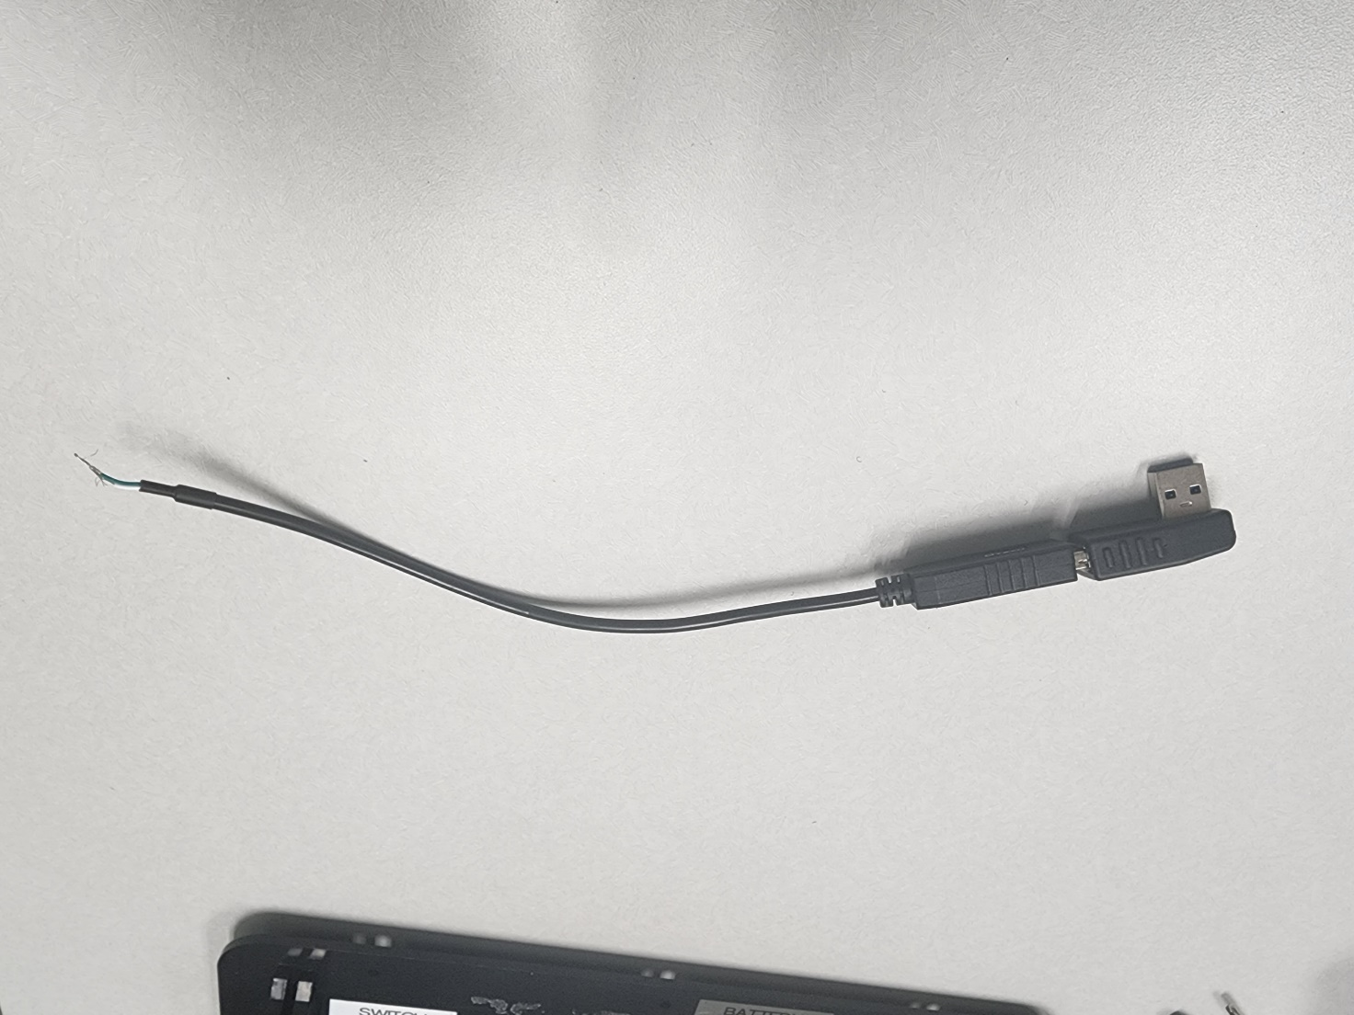

1. Wire the USB to TTL Cable’s (I/N: **40**) **White #0 & Green #1 pins** on the (C/D: **J1**) Teensy 4.1 Terminal Board (I/N: **34**)

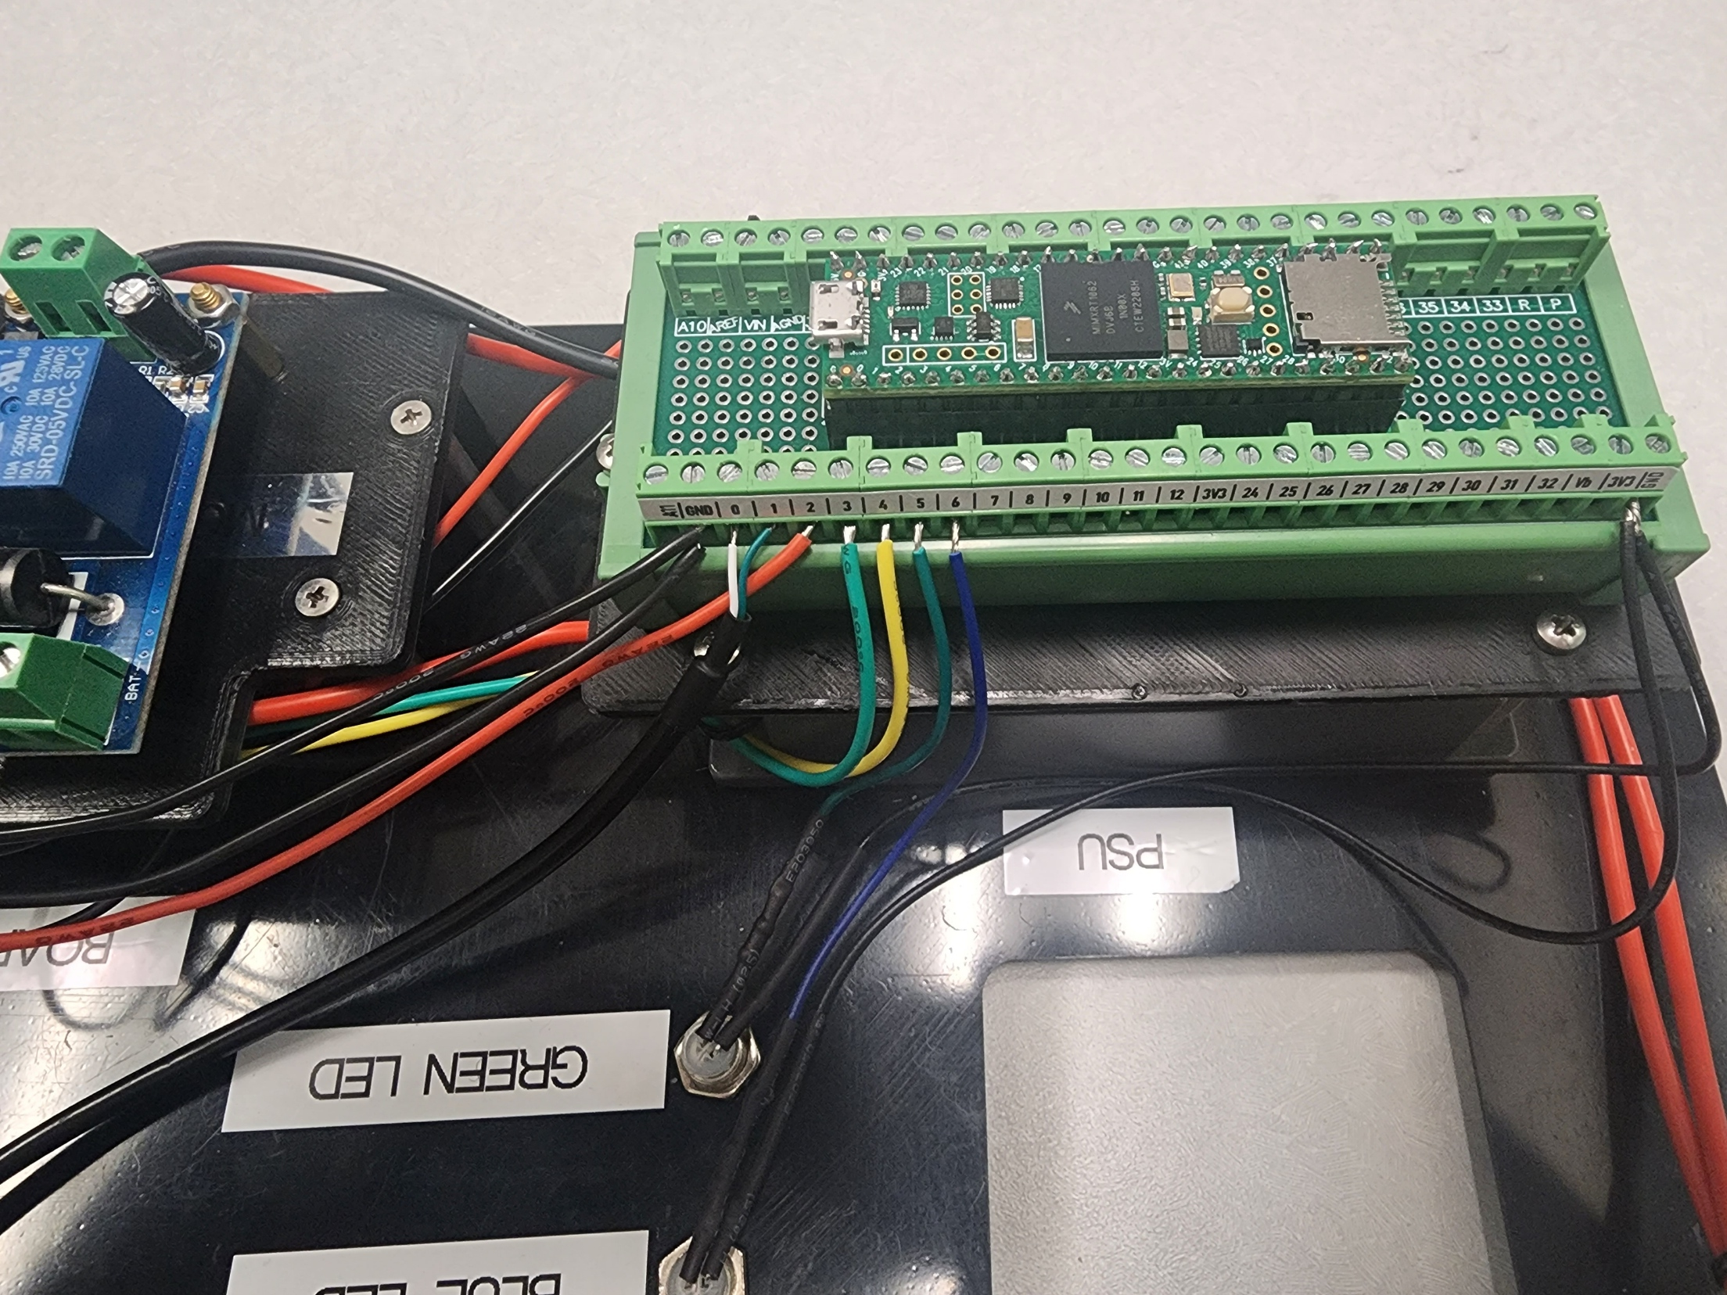

1. Wire the male end of the (C/D: **CN2**) 2-Wire Quick-Disconnect Connector’s (I/N: **64**) to the **DC- & DC+ pins** on the (C/D: **K1**) Battery Switching Relay (I/N: **33**)
2. Wire the male end of the (C/D: **CN2**) 2-Wire Quick-Disconnect Connector’s (I/N: **64**) to the **Bat- & Bat+ pins** on the (C/D: **K1**) Battery Switching Relay (I/N: **33**)

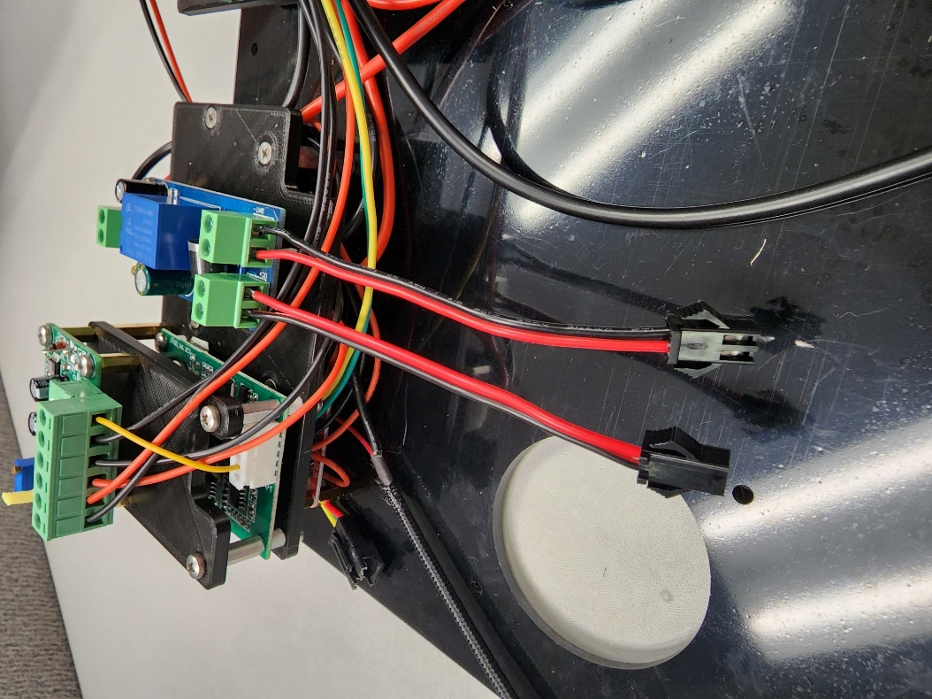

# **Process 14: Build Flow System**

## Required Parts:

|  |  |  |  |
| --- | --- | --- | --- |
| Item Number (I/N) | Part Number (P/N) | Quantity | Part Description |
| 7 | 99186A143 | 1 | 44mm Rubber Washer |
| 8 | 9540K747 | 3 | Rubber Bumper |
| 9 | 2930T55 | 1 | Steel Cloth Screen Disc |
| 10 | 5300-IF-LP | 1 | TSI Inlet Filter |
| 11 | 5233K52 | * | Silicone Tubing for Differential Pressure Sensor |
| 12 | 9561K16 | 1 | O-Ring Small (-015) |
| 13 | 9561K24 | 1 | O-Ring Big (-022) |
| 14 | JYQD_V7.3E2 | 1 | 24v BLDC Motor Controller |
| 15 | U65ML-024KS-5 | 1 | BLDC Fan Blower |
| 16 | 5310-2 | 1 | TSI Flow Meter |
| 17 | LR4P-USBMF | 1 | 90° USB 3.0 Adapter |
| 19 | B07RX7Z9ZW | 1 | Ribbon Cable |
| 20 | a19042900ux0610 | 1 | Ribbon Cable Extension Board |
| 21 | FC-003 | 1 | Pitot Top |
| 22 | FC-004 | 1 | Pitot Bottom |
| 23 | FC-005 | 1 | BLDC Fan to Filter Adapter |
| 40 | DT-6560-1.8m | 1 | USB to TTL USB Cable |
| 46 | 98952A120 | 3 | 5mm + 25mm Male & Female Standoff |
| 47 | 95947A063 | 4 | 31mm Standoff |
| 49 | 93475A210 | 3 | M3 Washer |
| 56 | 90116A153 | 4 | M3x8mm Pan Head Screw |
| 59 | 92010A122 | 4 | M3x12mm Flat Head Screw |
| 61 | FC-010 | 1 | Silicone Inlet Gasket |
| 64 | CAB-14574 | 1 | 2-Wire Quick-Disconnect Connector (Both Ends) |

## Steps: Part 1

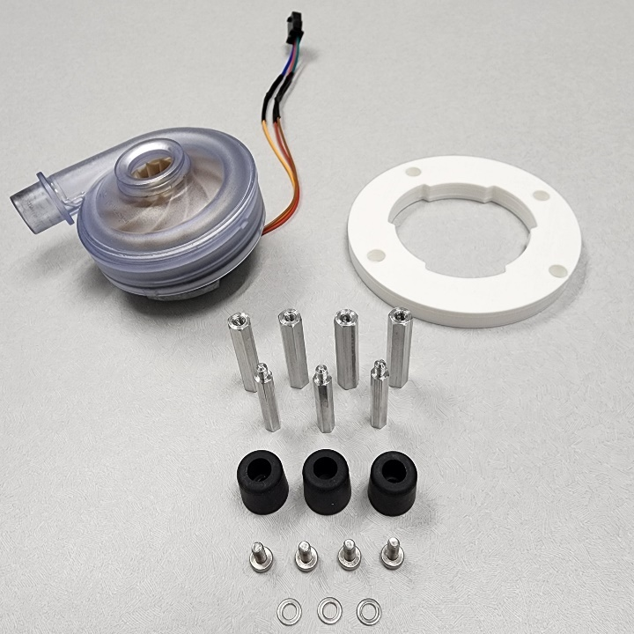

1. Fasten (3x) 31mm Standoff’s (I/N: **47**) to the Pitot Bottom (I/N: **22**) using (3x) 5mm to 25mm Male & Female Standoff’s (I/N: **46**)
2. Fasten a 31mm Standoff (I/N: **47**) to the Pitot Bottom (I/N: **22**) using an M3x8mm Screw (I/N: **55**)
3. Fasten (3x) Rubber Bumper’s (I/N: **8**) to the 5mm to 25mm Male & Female Standoff’s (I/N: **46**) using (3x) M3x8mm Screw’s & (3x) M3 Washer’s (I/N: **56, 49**)

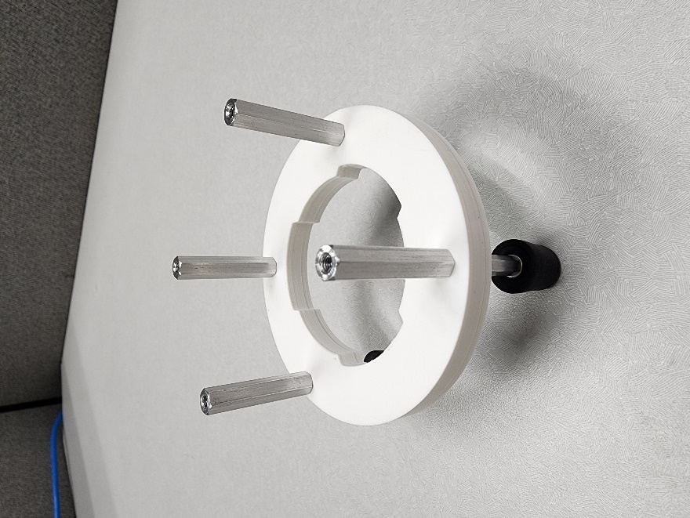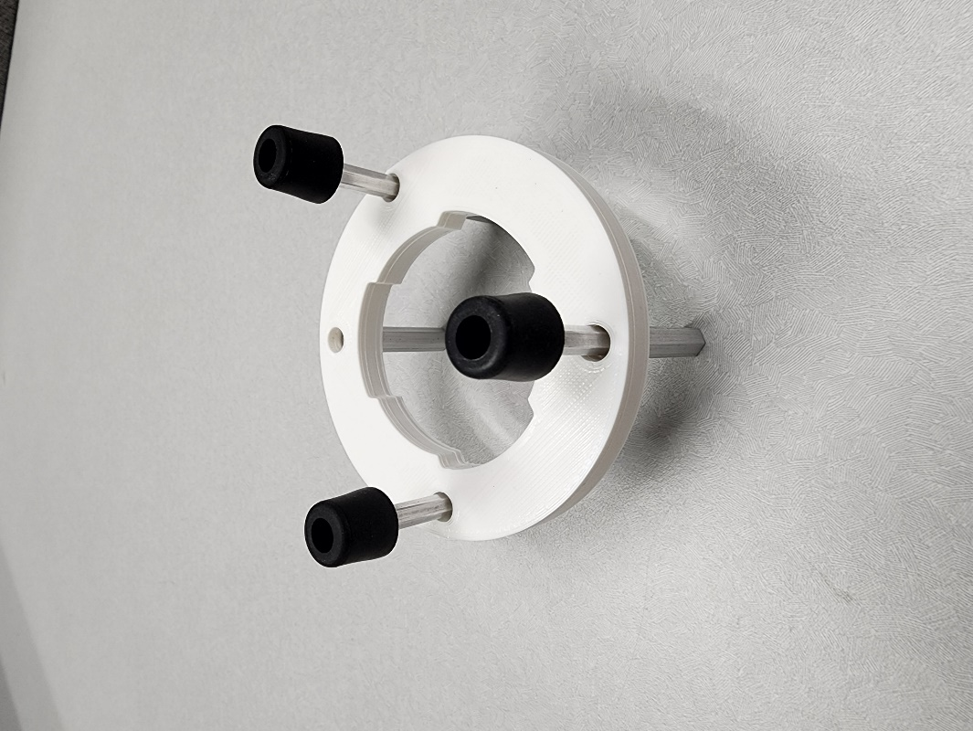

1. Insert the BLDC Fan Blower (I/N: **15**) into the Pitot Bottom (I/N: **22**)

Note: This will now be referenced as the Bottom Pitot Assembly

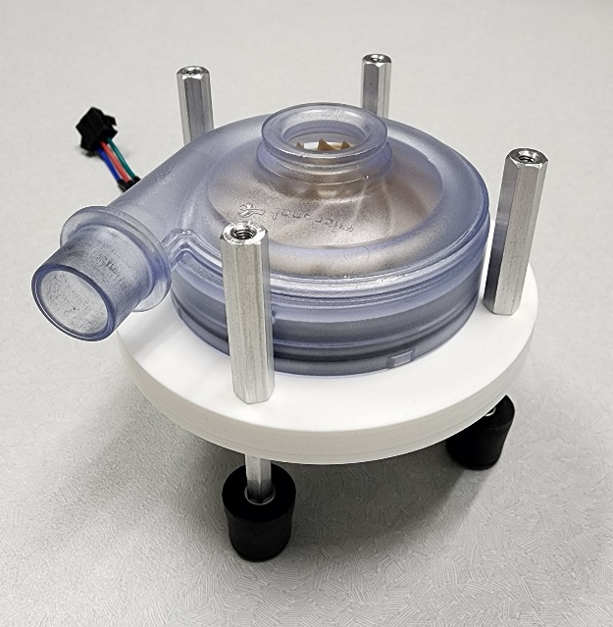

## Steps: Part 2

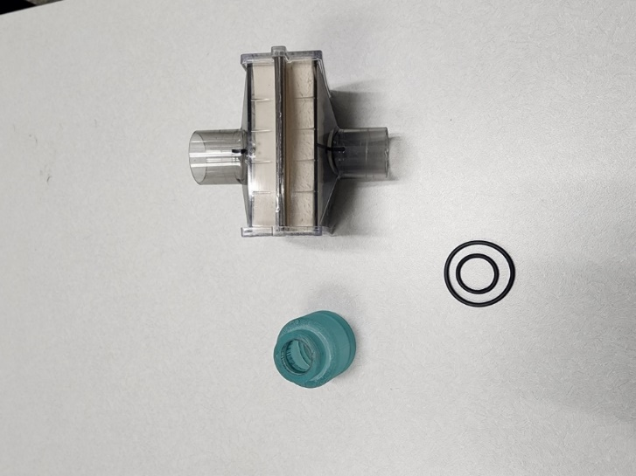

1. Insert a size -015 (I/N: **12**) & -022 (I/N: **13**) O-ring into the BLDC Fan to Filter Adapter (I/N: **23**)

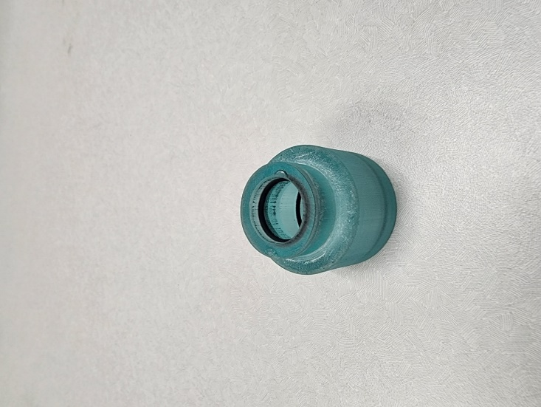

1. Insert TSI Inlet Filter (I/N: **10**) into the BLDC Fan to Filter Adapter (I/N: **23**)

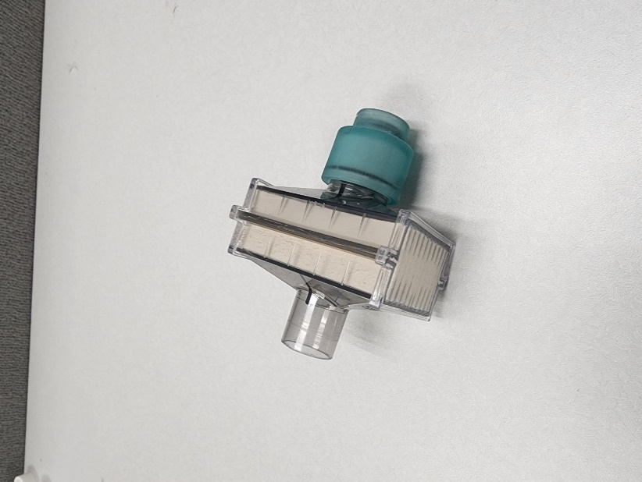

1. Insert the BLDC Fan to Filter Adapter assembly onto the Bottom Pitot assembly

Note: This will now be referenced as the Bottom Pitot Assembly

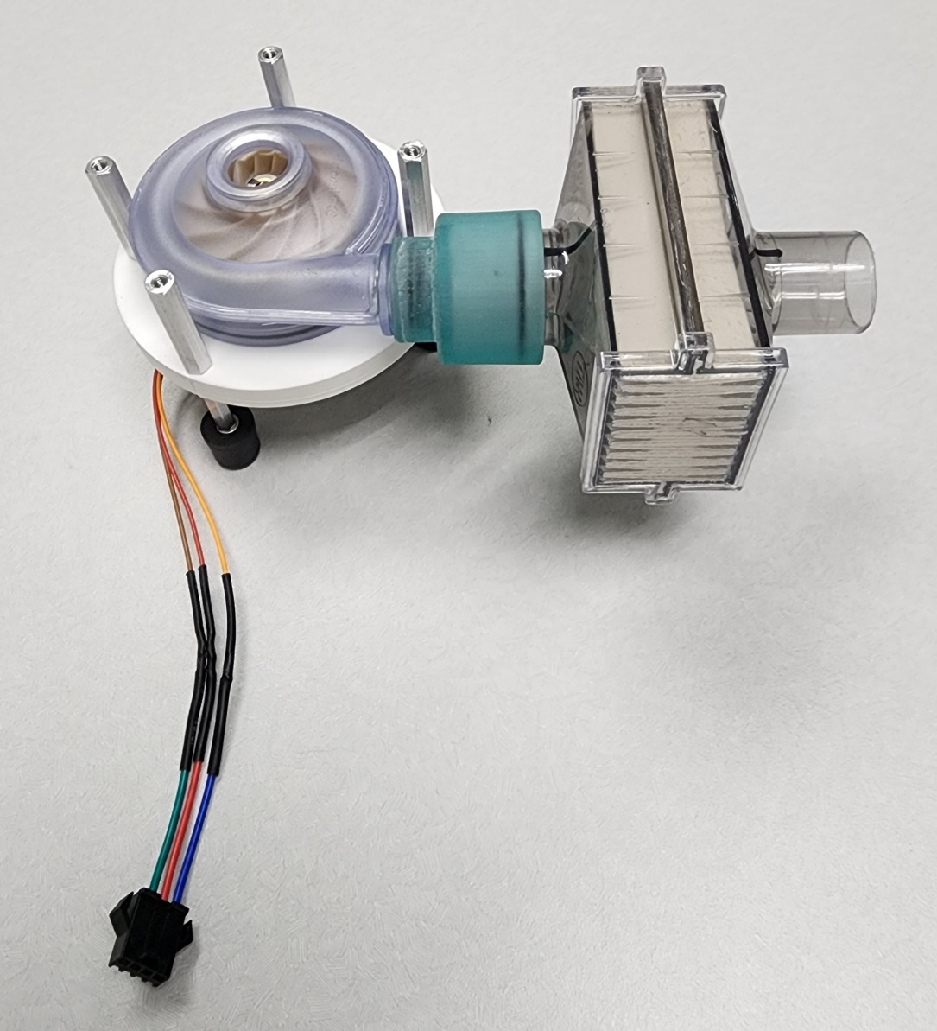

## Steps: Part 3

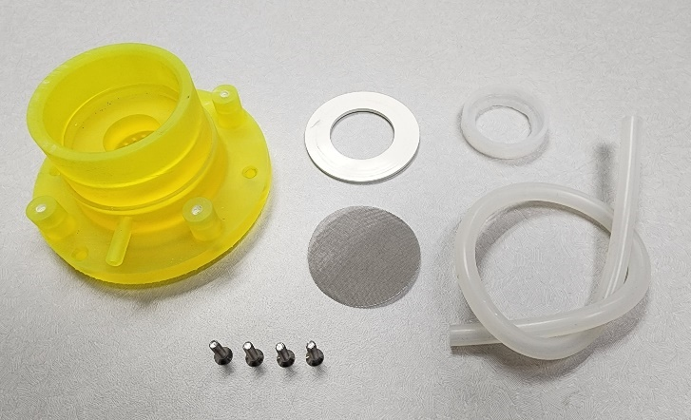

1. Insert the 44mm Rubber Washer (I/N: **7**) & Steel Cloth Screen Disc (I/N: **9**) into the Pitot Top (I/N: **21**)

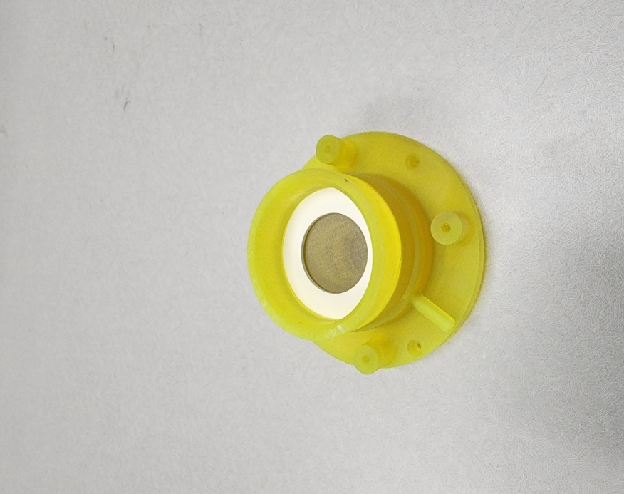

1. Disassemble the Flow Meter (I/N: **16**)

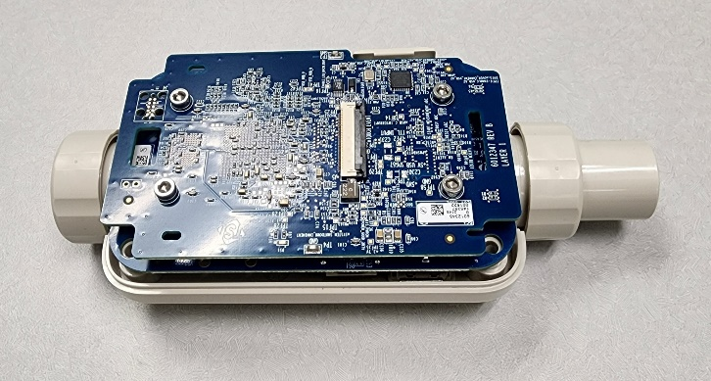

1. Connect the Ribbon Cable (I/N: **19**) & the Extension Board (I/N: **20**) to the Flow Meter (I/N: **16**)

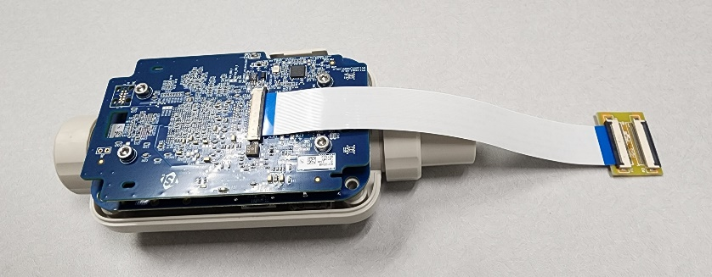

1. Insert the Flow Meter (I/N: **16**) into the Rubber Sealing Gasket (I/N: **3**) inside the Pelican Case (I/N: **1**)

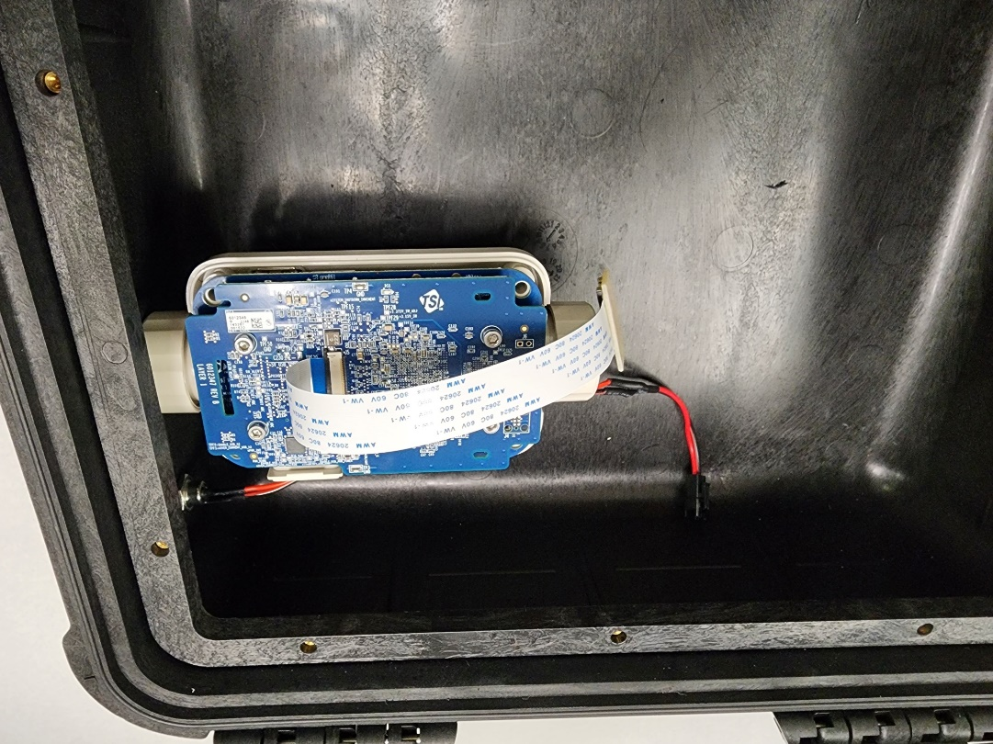

1. Insert the Bottom Pitot Assembly into the Flow Meter (I/N: **16**)

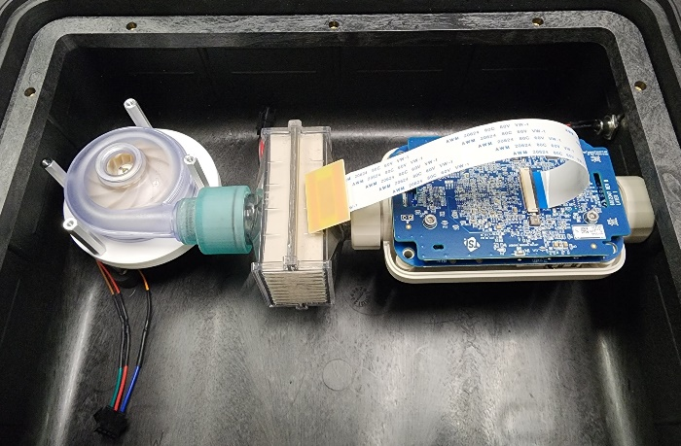

1. Insert the Silicone Inlet Gasket (I/N: **60**) onto the BLDC Fan Blower (I/N: **15**)

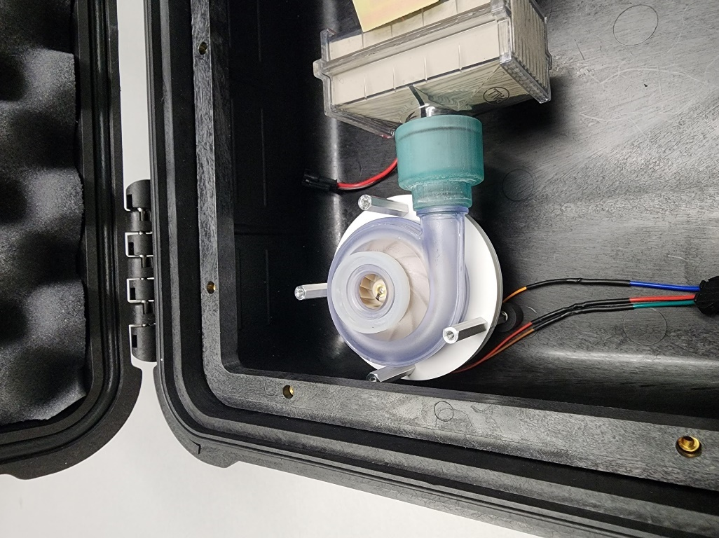

1. Fasten the Pitot Top (I/N: **21**) & Pitot Bottom (I/N: **22**) assemblies together with 4x 12mm Screws (I/N: **59**)
2. Insert Silicone Tubing (I/N: **11**) from the Pitot Assembly to the **Negative(-)** pressure port on the TSI Flow Meter (I/N: **16**)

Note: This will now be referenced as the Flow Assembly

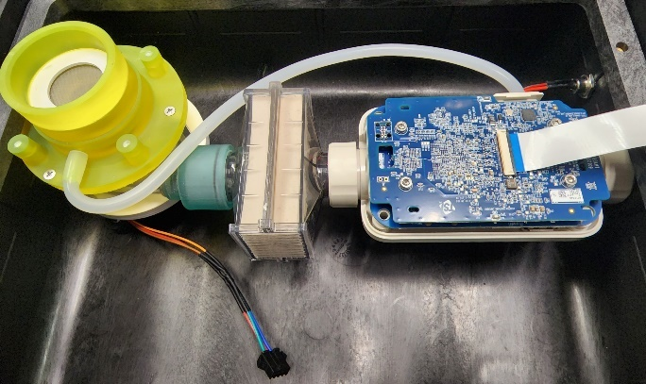

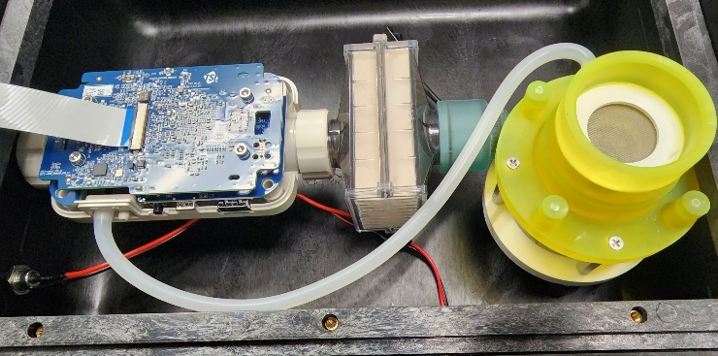

# **Process 15: Install the Battery**

## Required Parts & Tools:

|  |  |  |
| --- | --- | --- |
| Item Number (I/N) | Part Number (P/N) | Part Description |
| 1 | 1400 | Pelican Case |
| 29 | CU-J294 | 25.6v Rechargeable Battery |
| 44 | 9273K15 | Velcro Strips |
| 64 | CAB-14574 | 2-Wire Quick-Disconnect Connector (Female End) |

## Steps:

1. Cut 2x (Loop Side) Velcro Strips (I/N: **44**) to 5.5in
2. Peel & stick both (Loop Side) Velcro Strips (I/N: **44**) to the (C/D: **G1**) 25.6v Rechargeable Battery (I/N: **29**)

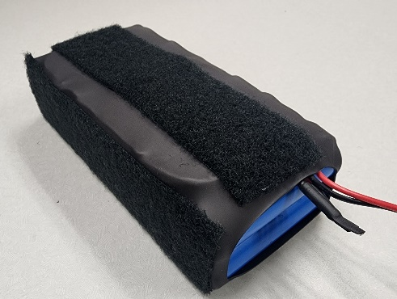

1. Solder & Heat-shrink the female end of the (C/D: **CN2**) 2-Wire Quick-Disconnect Connector’s (I/N: **64**) Positive (**RED**) & Negative(**BLACK**) leads to the Positive (**RED**) & Negative(**BLACK**) leads on the (C/D: **G1**) 25.6v Rechargeable Battery (I/N: **29**)

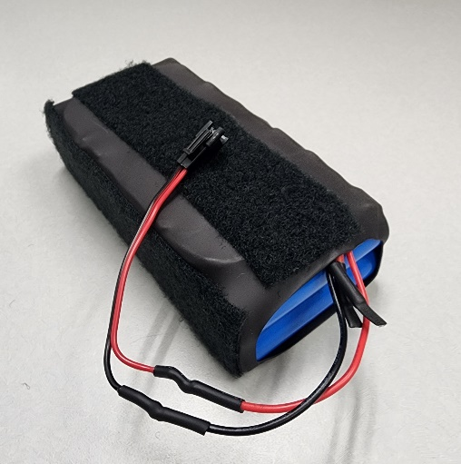

1. Stick the (C/D: **G1**) 25.6v Rechargeable Battery (I/N: **29**) to the inside of the Pelican Case (I/N: **1**)

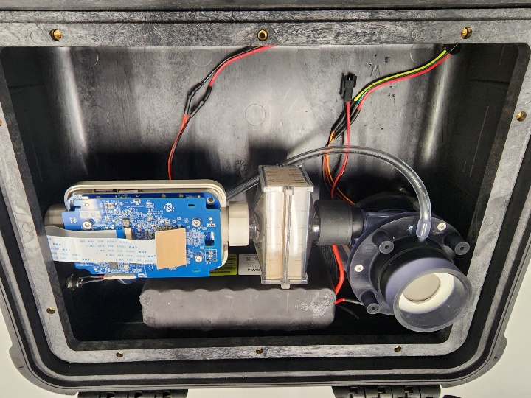

# **Process 16: Install Display Holder**

## Required Parts:

|  |  |  |  |
| --- | --- | --- | --- |
| Item Number (I/N) | Part Number (P/N) | Quantity | Part Description |
| 16 | 5310-2 | * | TSI Flow Meter’s Display |
| 25 | FC-009 | 1 | Display Holder |
| 55 | 91828A211 | 4 | M3 Hex Nut |
| 59 | 92010A122 | 4 | M3x12mm Flat Head Screw |

## Picture of Required Components:

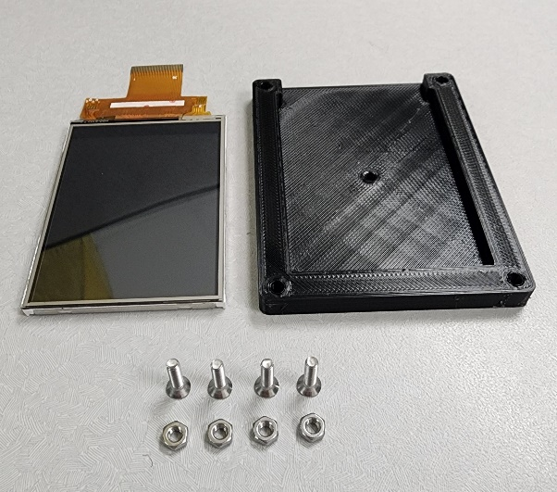

## Steps:

1. Insert the TSI Flow Meter’s Display (I/N: **16**) into the Display Holder (I/N: **25**)

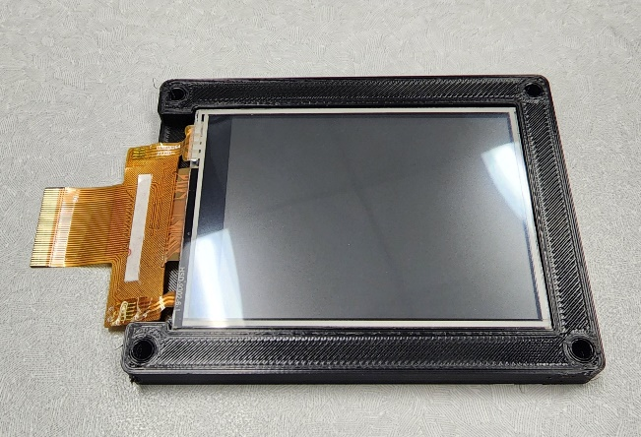

1. Fasten the TSI Flow Meter’s Display (I/N: **16**) to the Control Panel (I/N: **4**)

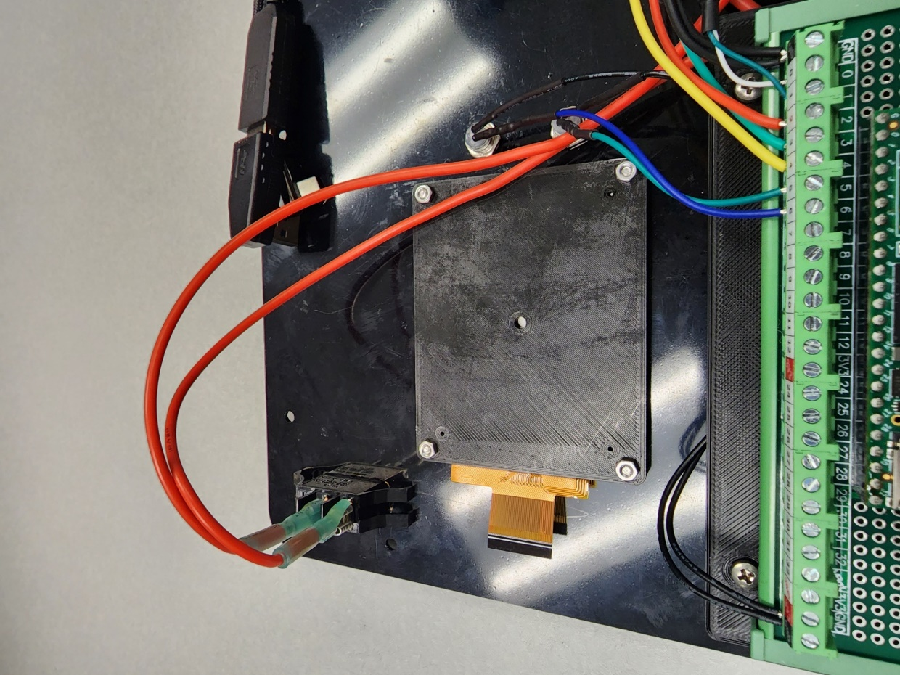

# **Process 17: Install Control Panel**

## Required Parts:

|  |  |  |  |
| --- | --- | --- | --- |
| Item Number (I/N) | Part Number (P/N) | Quantity | Part Description |
| 45 | 91771A943 | 10 | #6-32x7/16” Flat Head Screw |
| 59 | 92010A122 | 4 | M3x12mm Flat Head Screw |
| 61 | FC-011 | 1 | Silicone Dust Plug |

## Steps:

1. Plug the TSI Flow Meter’s Display (I/N: **16**) into the TSI Flow Meter (I/N: **16**)
2. Plug the USB-C Cable (I/N: **18**) into the TSI Flow Meter (I/N: **16**)
3. Plug the (C/D: **M1**) BLDC Fan Blower (I/N: **15**) into the (C/D: **E1**) 24v BLDC Motor Controller (I/N: **14**)
4. Plug the (C/D: **K1**) Battery Switching Relay (I/N: **33**) into the (C/D: **G1**) 25.6v Rechargeable Battery (I/N: **29**)
5. Plug the (C/D: **K1**) Battery Switching Relay (I/N: **33**) into the (C/D: **CN1**) Power Plug (I/N: **28**)
6. Plug the USB to TTL Cable (I/N: **40**) into the bottom of the TSI Flow Meter (I/N: **16**)
7. Seat the Panel Gasket to the Panel Kit Accessory (I/N: **2**)

Note: The Panel Kit Accessory (I/N: **2**) ships with the Panel Gasket

1. Seat the Control Panel (I/N: **4**) onto the Panel Gasket and the Panel Kit Accessory (I/N: **2**)
2. Fasten the Pitot Top (I/N: **21**) to the Control Panel (I/N: **4**)
3. Fasten the Control Panel (I/N: **4**) to the Panel Kit Accessory (I/N: **2**)

# **Process 18: Install Decal**

## Required Parts:

|  |  |  |  |
| --- | --- | --- | --- |
| Item Number (I/N) | Part Number (P/N) | Quantity | Part Description |
| 5 | FC-007 | 1 | Decal |
| 24 | FC-006 | 1 | Verification Orifice |
| 30 | OWA-60U-30 | 1 | 30v Power Supply |

## Steps:

Caution! Only complete this step once all device testing and verification is complete. The Decal covers all visible fasteners once the adhesive is cured.

1. Stick the Decal (I/N: **5**) to the Control Panel (I/N: **4**)
2. Insert the Verification Orifice (I/N: **24**) into the Pitot opening
3. Attach Velcro to the 30V Power Supply (I/N: **30**) & stick it to the top middle of the Control Panel (I/N: **4**)
4. Shut the lid on the Control Panel (I/N: **4**)

# **Conclusion:**

You have now completed the FilterCheck’s Assembly Manual! For questions and/or concerns regarding the FilterCheck please contact **Ator Labs** at: [LAD@AtorLabs.com](mailto:LAD@AtorLabs.com).